Honoa te pito ora ki te pito mate

Live Kidney Donation Aotearoa

(January 2013 – June 2016)
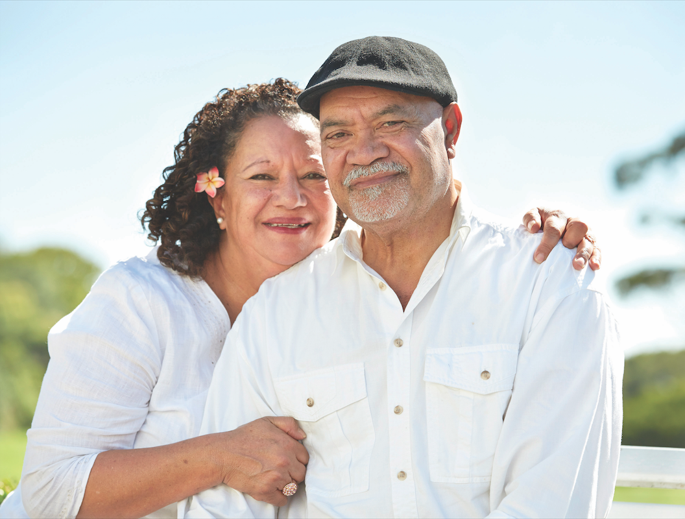

Evaluation Report for the Ministry of Health

September 2016
Susan Reid (Health Literacy NZ) and Sneha Shetty (Counties Manukau Health) on behalf of the Live Kidney Donation Aotearoa Steering Committee.

Table Of Contents:
1. Executive Summary 4
2. Introduction 6
2.1. Overview of the project 6
3. Evaluation Plan 9
3.1 Evaluation Plan, methods and participants 9
3.2 Evaluation method, recruitment and data collection 11
4 Findings 13
4.1 Overall Project Outcomes and Live Kidney Donors Experience of the Service 13
4.1.1 Numbers of Live Kidney and Pre-emptive transplants 13
4.1.2 Numbers of Live Donor offers 13
4.2 The Home and Kidney First Policy 15
4.3 Live Kidney Donors Experience of the Renal Service 16
4.4 Educational Resources 20
4.4.1 Post Resource Development Evaluation Stage 20
4.5 Home Based Education Programme 24
4.5.1 Evaluation Results 24
4.6 Peer Support Programme 29
4.6.1 Evaluation 30
4.7 Pre-dialysis Education 32
4.7.1 Burden of seeking a donor 32
4.7.2 Un-met educational needs 33
4.7.3 Emotional upheaval 36
4.7.4 Imposition on donor 37
4.7.5 Awareness of cultural influence 38
4.8 Primary Care Providers Education, Community & Community Leader Engagement 39
4.8.1 Findings Market research Stage 1 (health professionals and experts) 39
4.8.2 Findings Market research Stage 2 41
5 Discussion 43
5.1 Change Project 43
5.2 Education Resources 43
5.3 System issues 44
5.4 Communication and patients - practitioner interactions 44
5.5 Home Based Education and Peer Support programmes 44
5.6 Pre-dialysis 45
5.7 Finding a donor 45
5.8 Home & Kidney First Policy 45
5.9 Health Literacy 46
5.10 Primary care 46
6 Conclusions 47
7 Recommendations 48
7.1 For District Health Boards who are considering a similar project 48
7.2 For CMH's renal service 48
8 References 50
9. Acknowledgements 51
10. Appendices 52
10.1 Live Donor Kidney Transplants by Year 52
10.2 Live Donor Kidney Transplants by Month 53
10.3 Total Kidney Transplants (Live + Deceased) by Month 54
10.4 Pre-emptive Live Donor Kidney Transplants by Year 55
10.5 Live Kidney Donor Offers by Year 56
10.6 Number of Potential Donor Offers by Month 57
10.7 Home Based Education, Peer Support Programme and Renal Service Experience Evaluation Interview Guide 58
10.8 Pre-dialysis Education Evaluation Interview Guide 59
10.9 Market Research Stage 1 and Stage 2 Reports 60

Executive Summary

This evaluation report provides strong evidence that the Live Kidney Donation Aotearoa (LDKA) project has been successful in achieving the primary aim of the project, which was to increase the number of live kidney donor transplants for Counties Manukau Health’s Pasifika and Maaori patients. While the number of transplants did not quite reach the target (20 Live Kidney Donor Transplants per year and 10 pre-emptive transplants by June 2016), the number of donor offers received throughout the term of the project far exceeded the target set. This demonstrates that the LKDA project generated awareness amongst patients and their whaanau about live kidney transplants and donation. Whaanau and friends of Pasifika and Maaori patients will offer to donate notwithstanding the lack of adequate financial assistance to ensure donors are not out of pocket as a result of donation.

The LKDA project was not successful in engaging primary care or the community. Both these groups are critical to driving real change. In particular as identified by the evaluation of the pre-dialysis service raising community awareness and engagement will assist patients with the difficult task of asking for donors. In the same way engagement with primary care will help ensure that patient receive consistent advice about live kidney transplants from all health professionals, and prospective donors can be assisted to address the clinical issues that are preventing some from donating. The market research undertaken as part of this project has made recommendations that have the potential to address some of these issues. There was not time to fully consider and implement these recommendations during the period of the project. This will be addressed as part of integrating the LKDA model into the renal service as business as usual.

This report also contains strong evidence of consumer and system level changes brought about the various interventions implemented as part of the LKDA project. The evaluation of key interventions such as the Home and Kidney First policy, the education resources, home based education and peer support programmes prove that each of the interventions have been valued by the patients and donors whilst also identifying some areas for improvement.

The key areas for improvement include:
- Integration of the individual interventions to provide a seamless service. Although each of the interventions has been successful to some extent in meeting the specific patient/donor needs there is still a need for optimisation of these interventions.
- Developing metrics around the Home and Kidney policy has the potential for renal service staff to increase the number of referrals for home-based education and peer support programmes.
- Improved communication with the patients/donors – communication between patients and clinicians has been highlighted as a consistent and critical area for improvement This indicates the need for further work to be conducted to embed the health literacy approach consistently within the service.
- Lack of support for donors post donation – there is a general feeling of abandonment by the donors post-surgery. There is an opportunity here to utilise the peer support programme beyond the original scope of pre-donation to include post –donation as well.
- Investigate how the service could be streamlined to reduce the complexity of the work-up process for donors.

Introduction

This report contains evaluation data from the Live Kidney Donation Aotearoa (LKDA) project at Counties Manukau Health (CMH) from January 2013 to June 2016.

This report:
- provides information about the success of LKDA in meeting its overall objectives as per the original contract with the Ministry of Health,
- examines the effectiveness of the interventions implemented by LKDA
- identifies the areas for improvement.

Overview of the project

The LDKA project is a collaborative initiative driven by the Kidney Society (Auckland) and CMH. Steering Committee comprised the following individuals:

- Mark R Marshall, Chair, Clinical Director, Department of Renal Medicine, CMH
- Nora van der Schrieck, Executive Director, Kidney Society (Auckland)
- Caran Barrat-Boyes, Community Liaison, Maaori Health/Department of Diabetes-Endocrinology, CMH
- Catherine Tracy, Service Manager, Division of Medicine, CMH
- Denise Beechey, Nurse Specialist, Department of Renal Medicine, CMH
- Michael Lam, Transplant Nephrologist, Department of Renal Medicine, CMH
- Viliami Tutone, Nephrologist, Department of Renal Medicine, CMH
- Hla Thein, Nephrologist, Department of Renal Medicine, CMH

with the support of the following other individuals

- Hari Talreja, Nephrologist, CMH
- Lisa Hoyle, Health Psychologist, Division of Medicine, CMH
- Jonathan Gray, Clinical Director, Ko Awatea
- Susan Reid, Director, Workbase
- Tony Murrow, Director, Murrow and associates
- Richards Partners.

The aims of the LKDA project were:

Primary Aim Statement:
To increase the number of live kidney donor transplants for CMH Pasifika and Maaori patients by 20 per year, by the end of Year 4 (June 2016).

Secondary Objectives:
To increase the number of potential donors offering live kidneys to CMH Pasifika and Maaori patients through the achievement of the following objectives.

1. To develop and trial culturally sensitive and health literacy appropriate educational resources for live kidney donation in Pasifika and Maaori, by the end of the Year 1 (December 2013).

2. To develop an inclusive Home-Based Live Kidney Donor Education Programme using ethnically based health educators trained to build patients’ and families’ health literacy skills, provided for every clinically appropriate Pasifika and Maaori patient.

3. To identify and educate lay volunteers within patients’ social networks who can provide information on end-stage kidney disease and live kidney donation, and build patients’ and families’ health literacy around the process and outcomes of offering.

4. To develop and implement a “Home and Kidney First” policy at CMH, by the end of the Year 1(December 2013).

5. To improve patients’ health literacy and understanding of the benefits and process of pursuing live kidney donor transplantation in the pre-dialysis setting.

6. To increase the understanding and knowledge of Primary Care Providers around live kidney donation, to enable them to support and share appropriate information and build health literacy with patients and their families / whaanau / friends / associates at the most appropriate and earliest time.
7. To have developed a community engagement framework for CMH Pasifika and Maaori communities, by the end of the 1st year, resulting in an average of quarterly large scale community engagement sessions which build health literacy at culturally appropriate venues (Churches, Marae, non-healthcare support groups) over the 4 years.

8. To have developed a community-leader engagement framework including health literacy for CMH Pasifika and Maaori community leaders, by the end of Year 1 (December 2013).

These aims are represented in Figure 1 below:

Figure 1: Schema illustrating the relationship between Primary Aim and 8 Secondary Objectives

Evaluation Plan

Evaluation Plan, methods and participants

This table is a summary of the evaluation methods used for the project. Considering the multi-faceted approaches used throughout the LKDA project both quantitative and qualitative methods have been used for the evaluation. There is more information about the qualitative methods used for Deliverables 4, 5, 6, and 8 later in this section.
No. | Deliverable | Indicators | Additional | Source
1. | Achieve yearly increase in the number of live kidney donor transplants during the course of the proposed Project, with a target of 20 in total per annum, by Year 4 of this project. | Number of live kidney donor transplants at the end of each year | Number of Maaori and Pasifika live kidney donations | Quantitative data
2. | Achieve yearly increase in the number of pre-emptive live kidney donor transplants during the course of the proposed Project, with a target of at least 10 out of the 20 in total per annum, by Year 4 of this project. | Number of pre-emptive live kidney donor transplants | Number of Maaori and Pasifika pre-emptive live kidney donor transplants | Quantitative data
3. | Achieve a yearly increase in the number of potential donors being actively worked up during the course of the proposed Project, with a target of 20 complete work-ups per annum and 30 new initiations of work-up per annum, by Year 4 of this project | Number of potential donors being actively worked up per year | Number of potential donor offers made per year | Quantitative data
4. | The development and trial of culturally sensitive and health literacy appropriate educational resources for live kidney donation in Pasifika and Māori. | Number and description of educational resources (as per product description)  Pre and post patient experience feedback | Number produced  Number distributed | Quantitative data (number produced and distributed)  Qualitative data from donor and recipient interviews conducted after the development of the resources
5. | The development of an inclusive Home-Based Live Kidney Donor Education Programme. Using ethnically based health educators trained to build patients’ and families’ health literacy skills. | Description of programme developed and implemented  Number of home based education sessions conducted  Patient experience feedback | Number of donor offers made post home based education sessions | Quantitative data  Qualitative data from donor and recipient interviews conducted post implementation of the intervention
6. | The identification and education of lay volunteers within patients’ social networks who can provide information on end-stage kidney disease and live kidney donation. In addition, build patients’ and families’ health literacy around the process and outcomes of offering | Number of volunteers recruited  Number of sessions or contacts by volunteers  Patient experience feedback |  | Quantitative data  Qualitative data from donor and recipient interviews conducted post implementation of the intervention
7. | The development and implementation of a “Home and Kidney First” policy at CMDHB | Evidence of impact of the policy |  | Home & Kidney First Policy Audit
8. | The improvement of patients’ health literacy and understanding of the benefits and process of pursuing live kidney donor transplantation in the pre-dialysis setting | Pre-dialysis education evaluation  Impact of home & kidney first policy |  | Qualitative data from donor and recipient interviews conducted post implementation of the intervention
9. | An increase in the understanding and knowledge of Primary Care Providers around live kidney donation. To enable them to support and share appropriate information and build health literacy with patients and their families / whaanau / friends / associates at the most appropriate and earliest time. | PCP questionnaire  PCP contacts made |  | Did not proceed
10. | The development of a community and community leader engagement framework for CMDHB Pasifika and Māori communities. The aim is to build health literacy and awareness of live kidney transplant/donation. | Framework developed  Actions planned/taken | Number of community events conducted | Market Research Report

Evaluation method, recruitment and data collection

Deliverable 4: Development of educational resources for potential donors and recipients

All donors and recipients who had received the educational resources and expressed interest in providing feedback about the education resources were invited to take part in either focus groups or face-to-face interviews. Kidney Society Auckland (KSA) and staff from the renal service recruited participants. Participation was voluntary and verbal consent was obtained prior to participation. Interviews took place from August to October 2015. Notes were taken by the interviewers and where agreed interviews were audio recorded. One participant gave feedback by email.

Deliverables 5 and 6: Home based education, peer support programme and renal services

54 patients who had used home based education and/or the peer-support programmes, or were donors who received usual renal healthcare services, were invited to take part in a short 15-minute telephone interview about their experiences of the different services. A female health psychologist intern conducted the telephone interviews using a one-off semi structured interview guide (see Appendix 10.7). There was no established relationship between the interviewer and participants prior to data collection. Participants were recruited over the telephone and recruitment continued until patients either completed an interview or had been telephoned three times with no response. Participation was voluntary and verbal consent was obtained prior to participation.

From the patients on the calling list:
- 18 were excluded
- four were unreachable as calls went to voice mail
- eight were unreachable due to either an invalid number or unknown contact details
- one patient could not remember the service
- three patients were hearing impaired
- one patient could not speak English
- one patient declined to participate.

Interviews took place from 10 March 2016 to 27 April 2016. Each telephone interview was audio recorded and transcribed. The duration of interviews ranged from five minutes to 15 minutes. Data saturation was not considered, as there were a limited number of participants. Transcripts were not returned to participants for comment and/or correction.

A total of 36 kidney patients (66% of the people on the list) completed the brief telephone interview.

- 25 participants had used the home-based education programme.
- Three had used the peer-support programme.
- Eight were donors who had not used the peer-support programme or the home-based education programme but provided feedback on the usual renal services they received.
- 20 of the participants were female
- Participants ranged in age from 17 to 68 years with a mean age of 45 years
- Fifteen participants identified as Pasifika, eight as Maaori, six as New Zealand European, three as Other European, three as mixed ethnicity and one as Chinese.

Deliverable 8: Pre Dialysis

The nephrologists and renal nurse specialists from within the renal service identified potential study participants. A third party contacted potential participants and the study was described to them. Potential participants were given an information sheet outlining the purpose of the evaluation and the interviews involved and invited to participate. Potential participants were then contacted to ascertain whether they are interested in participating in the study, to answer any questions they may have, and to arrange a convenient time and location for a semi-structured interview.

Participants were selected by purposive sampling, to ensure information rich data and an inclusive range of patient perspectives and characteristics e.g. demographic characteristics (age, sex, and ethnicity) and clinical characteristics (dialysis modality, pre-dialysis). The number of participants was determined once data saturation was achieved i.e. when no new data was collected.

Face-to-face, semi-structured interviews (see Appendix 10.8) were carried out to elicit participant’s perspectives regarding live kidney transplants. All participants were interviewed in a private office or via telephone as requested by the participant. With the consent of the participants, all interviews (ranging from 50 to 80 minutes) were audio-recorded and transcribed verbatim.

The researcher was not known to the patient but was identified as a clinician with experience in qualitative interviewing. In total 19 participants were included in this study, with interviews ranging from 48 to 82 minutes in duration.

Thematic analysis was used to identify the range of barriers and perceived reasons for the factors that influence the participant’s choice and perceptions of live transplant. The data was grouped into themes and the analysis identified relationships between themes. This method was used to develop descriptive thematic groupings, generate new insights and elicit a richer description of the data overall.

Findings

Overall Project Outcomes and Live Kidney Donors Experience of the Service

4.1.1 Numbers of Live Kidney and Pre-emptive transplants

The LKDA project has witnessed an increase in the rate of live kidney donor and pre-emptive transplants facilitated by CMH during the period of the project. However the numbers fall short of the objective of 20 live donor transplants and 10 pre-emptive transplants per year.

There has been a significant increase in the number of live kidney donor transplants within the duration of the LKDA project. The project has successfully delivered 30 live donor transplants for CMDHB patients between Jan 2014 and June 2016. A further 7 live donors were evaluated at CMDHB and completed donation for other DHB recipients. This compares favourably to an average of only 2 live donor transplants per year between 2006 and 2013.

The number of Maaori and Pasifika patients who received a live kidney donor transplant also increased during the project period. Between 2006 and 2013 there had been only two Maaori and three Pasifika patients who had received a live donor transplant. Since 2014, 5 Pasifika and 6 Maaori received a live donor kidney transplant, and a further 2 Pasifika were donors to non CMDHB recipients.

Attached as Appendices 10.1, 10.2, 10.3 and 10.4 are charts, which show the increase in live donor kidney transplants each year and each month from 2006 until June 2016, the end of the project.

Appendix 10.3 contains another chart showing the total kidney transplants (live and deceased) by month and year for the same period.

Pre-emptive transplants increased during the project, with four pre-emptive transplants since 2014 as compared to only two pre-emptive transplants between 2006 and 2013.
Attached as Appendix 10.4 is a chart which show the pre-emptive live donor kidney transplants each year and each month from 2006 until 2016.

4.1.2 Numbers of Live Donor offers

The original objective for the LKDA project was 30 live donor offers per year. This objective has been significantly exceeded with the project receiving an average of 78 offers per year since 2014. During the project these offers have included an average of 10 Maaori and 22 Pasifika donor offers each year.

Accurate records of live donor offers, (including their ethnicity) were not kept prior to the project. However staff within the renal service agreed that based on their experience, the renal service would have received on an average about 10 live donor offers per year for the earlier period.

However the transplant rates show that majority of these donor offers were not able to be converted to actual transplants. This indicates that although the LKDA project has successfully raised awareness amongst CMH patients and whaanau about live kidney donation there are other factors that have impacted on the ability of these donors to proceed to donate. Renal service staff identified the key factors influencing this conversion include eligibility of the potential donors and financial constraints.

The Home and Kidney First Policy

The aim of the policy was to effect a paradigm shift within the renal service so that routine consultations would include dedicating more time to discussing live kidney donation and finding donors with whaanau. The Home and Kidney First Policy implemented by CMH has encouraged changes in how the renal team approaches pre-dialysis patients (and others) in that transplant, and live kidney transplant, are promoted ahead of dialysis. This is reflected in the increased donations and donor offers.

Further work is still needed to help recipients find potential donors through raising community awareness about kidney disease and both deceased and live donor transplants

Live Kidney Donors Experience of the Renal Service

Eight participants who had not used the home-based education programme or the peer support programme provided feedback across a number of areas.

1. Improvement in donors' health literacy about the benefits and process for live kidney transplants
Most of the eight donors stated that the information available about live kidney transplants was helpful and informative.
“It was all there, explanatory. I just read through this booklet they gave me, all the information was in there for me to read”.
“The coordinators were really informative and good at telling you what’s going to happen. It was good yes. Until you actually go through it I think they offer these support people and I did talk to a few people that donated, so they do offer you that”.
“It was good, the nurse’s, the pre-op nurses were really helpful”.

2. Good standard of healthcare received
Four of the donors were positive about the healthcare they received.
“The coordinator nurse was really good, she was good value. And the work-up towards being a kidney donor was good, like having to see the psychologist and all that stuff”.
“The medical care has been excellent, I’m very happy with the care both at the hospital and the follow-ups. I just had my year check a few weeks ago, and I had some blood work and everything and they’re making very sure I’m in good health, so that’s all been good. I think the enthusiasm of the doctors and nurses and everyone I dealt with was brilliant”.
“They went through the procedures and all that, the doctors and nurses, just explaining everything. They were quite helpful”.

However not all participants had positive experiences. The other four donors reported that the standard of healthcare that they received was inadequate or could be improved.
“When I got to the hospital they didn’t have room for me in the kidney ward and I was put in a regular ward and that wasn’t good. I knew things that they didn’t know about getting prepared because they’d explained to me everything I needed to do and have done. When the nurses came they didn’t know that I needed to scrub with special soap or whatever and they’re looking around asking ‘Where can I get that?’ The doctor who checked me during the night said ‘Your kidney output is way too low we need to pump more fluids in’ so he opened up the IV, and the next morning the renal guy came in and said ‘What the heck is that wide open for, of course your outputs low, you’ve only got one kidney’. That caused me a lot of discomfort because they’d pumped too much fluid through. Those are things that wouldn’t have happened on the actual renal ward”.
“Even offer a little bit more support. I mean my brother gets a lot of support, he goes in a lot, but as a donor you get left in the dark. But just a little bit more support probably, especially when you’re like I have been; I haven’t recovered that well, I’ve had a lot of problems. Maybe going to the doctors every second or third week just to make sure you’re okay”.

3. Positive feelings and experiences associated with donating a kidney
Some live kidney donors said kidney donation was rewarding in some way.
“I couldn’t be happier about the end result; it’s a really good feeling to think that you’ve saved someone’s life, or at least the quality of their life. Getting a thank you from the person who received the kidney meant a lot to me. It was a sacrifice and I wouldn’t lie to anyone about that. Just one of those things, in my mind, how could you not do it? Because for a couple of weeks of discomfort you can save someone’s life. So it was good, good for me. You know everyone needs to feel good about themselves and their contribution in life. And maybe I’m not someone who goes down and volunteers at the food bank, but this is something I could do and it makes me feel better about what I leave behind in life”.
“I’ll do anything for the family. For any of my siblings I’ll do it, or for my parents. I was just all for it you know. Because there was a family member, my sister, I just jumped right in and said I’ll do it”.

Some participants also identified areas for improvement.

4. Financial assistance
Four of the eight donors reported that they received little financial assistance during the transplant process.
“As far as financial help, the government did bugger all. I think I got $300 from WINZ, so that was a huge financial burden. I’m self-employed so I can take as much time as I want, but no one is paying me for the time that I take off…the money that I lost, the appointments. I told WINZ that when I got home within a few days I was answering e-mails and phone calls… as I could answer a phone call as far as they were concerned I was back to work. So that was hugely disappointing and felt like I was being treated like someone who was trying to bludge off the system, instead of someone who saved the government hundreds of thousands of dollars probably. So as far as what it cost me, it was easily $10,000 probably more”.
“Other than the hospital board I got no help in terms of financial assistance or when I had to take time off work. Especially when you take off over a month at work, even though I got sick pay there were still things like going back and forth from the hospital, making appointments, those sorts of things. So I think donors should be compensated for that, considering we’re saving the taxpayer thousands of dollars by donating our body parts and taking people off of dialysis. I think that there should be more investment in donors and the government needs to take responsibility for that”.
“I think it was the fact that I had to take quite a bit of time off work. After and during appointments and all that, it was a hard thing having to use up my own annual leave, so after it left me a bit short for any leave that I needed to take over the year. But maybe like assisting people with leave or anything like that. The other thing … you have your post-operation appointment, and then your check-up 3 months later, they always tell you that you can always go and see your doctors, but that’s still $70 down the drain. I think support from the government… financial support”.
“Financially it’s really hard, yea, really hard… I didn’t have any time really to prepare myself financially. $300 a week and you’ve got to go through work and income as well. It’s rigmarole, trust me. That’s not a lot of money to live on, I mean my rent is $200 and that’s cheap, I don’t know how other people do it. … I’m in debt to my eyeballs…it is pretty stressful…And especially if you’re not well. I mean I’ve got two kids as well, that doesn’t help. I actually get more money on the Job Plus whatever it’s called than I did on the live donor organ. They don’t tell you a lot about that side of it. I think you should get 80% of your wages, I know they’re trying to do that. You try and do a good thing for somebody, dialysis costs the taxpayer a huge amount of money, but you really don’t get any thanks for it. In the end the live donor payments they only gave me eight weeks of $300. I know I did a good deed, but you don’t really feel like it when you struggle like this and now I’m financially in the s**t you know. It’s not really fair you know”.

5. Time-consuming work-up process
Most donors reported that the work-up process was too long and time-consuming.
“It took a long time, it took a year, I finally got the approval after about nine months of testing. It’s a long time to keep your spirits up, keep your enthusiasm going. I came out with one kind of hiccup along the way, and they said ‘One more test will tell us, do you want to do this one last test?’ It was kind of hard to say ‘Yes, I’ll keep going’. I had the chance to take an out and it was pretty darn tempting to take it, but I didn’t”.
“All the numerous tests I had to go through, they took far too long. I was treated as a healthy person, so I went on a waiting list for a healthy person; all the tests I had to do I had to wait a healthy person amount of time to get them done, didn’t matter that person I wanted to donate to was dying, see what I mean. If someone’s decided to donate, they should speed up the rate at which the tests are done, especially if you’re donating to a family member”.
“I guess the work-up process was quite long. We started in February last year, but we didn’t have the operation until December. It should be shorter”.

One donor was quite explicit that there were too many hassles involved in donating a kidney.
“There’s a lot that you’re expected to do. Like trying to get parking at Auckland Hospital and the money that we spent on parking, that’s a huge thing as well and because you’re just any other patient, and I guess you’re thinking in the back of your mind, ‘I’m trying to do a good thing here’. Whether or not you need someone to pick you up after a procedure, they could probably do more asking what you need done to help. In terms of what would make it easier for someone, not to have so many appointments in so many places; all this time and effort, it was just appointment after appointment after appointment and they’re all over the place, down in Middlemore, up in Auckland Hospital, the Botany Super Clinic”.

6. Insufficient information about live kidney transplants
Some donors mentioned that they wanted more information about live kidney transplants.
“There could have been more, that would have helped. I went to the internet to find out more information, because there’s never enough there. Yea, from my point the information that was provided was far too simple and needed to be a bit more detailed. I can’t remember off the top of my head, but it wasn’t specific enough for me. I’ve got a science degree, so I like everything a bit pedantic. Whereas I’m sure most people wouldn’t have needed it to the level I wanted it”.
“What I think should be done is more like seminars, like take a whole approach to it and have like an evening where you talk about things to donors and have donors there that have been through the experience. I think that’s more helpful than reading a book. I was never invited to anything like that”.

7. Fears about transplant surgery
One donor stated that they experienced fear about going through the surgery.
“You’ve got fears obviously of what’s going to happen to both of you, but that’s just one of those things you got to work through it. I don’t think anybody can do much for you”.

Educational Resources

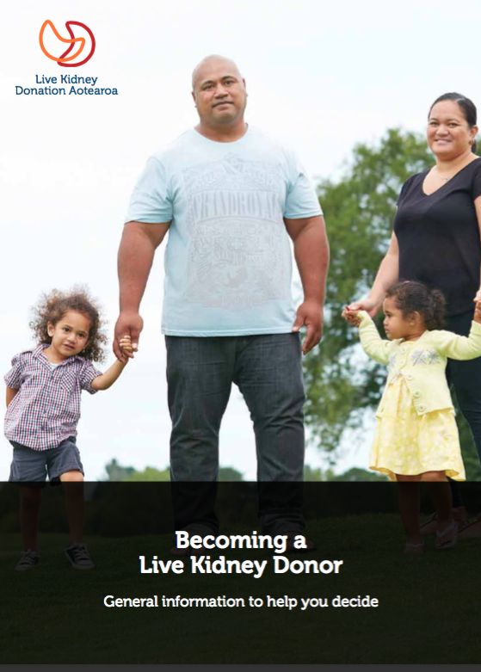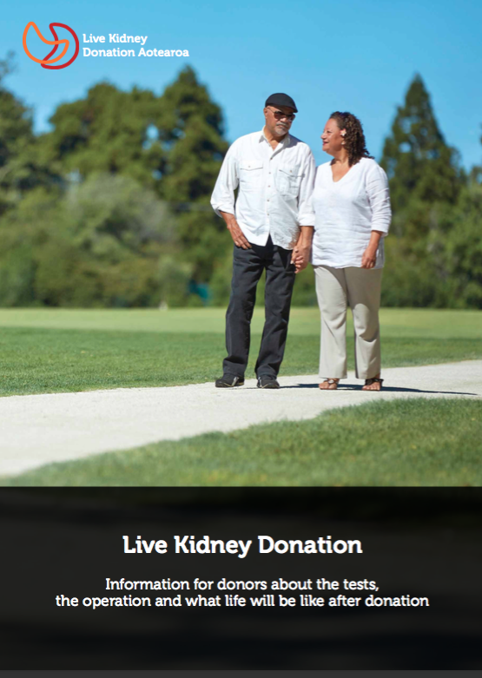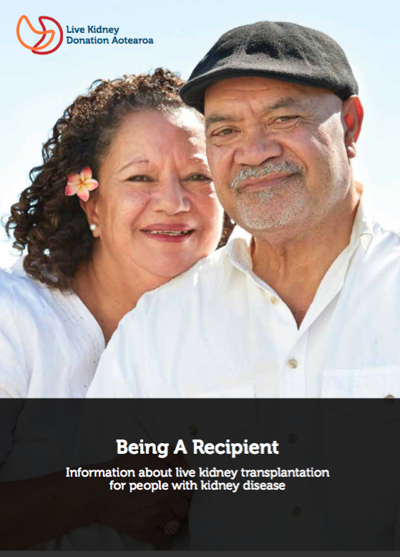

Post Resource Development Evaluation Stage

Three educational resources were developed and launched on 26 April 2014.THe resources were Becoming a Live Kidney Donor, Live Kidney Donation and Being A Recipient.

The development of the three resources followed the eight stages in Rauemi Atawhai A guide to developing health education resources in New Zealand (Rauemi Atawhai) (Ministry of Health, 2012.) This ensured that both donors and recipients and potential donors and recipients were interviewed in some depth both prior to the drafting of the resources and when testing the draft resources.

Earlier feedback from donors included:
- emotional Impact
- time taken for the work-up process
- communication and patient-practitioner interactions
- financial support
- importance of support people
- system issues ( designed for sick people)
- donation process

Earlier feedback from recipients included:
- finding donors’
- information’
- communication and patient-practitioner interactions
- time taken for work up process
- need for support
- financial issues’
- emotional impact’
- confronting nature of mortality data for dialysis versus transplant.

This earlier feedback has been included in this section of the report so comparisons can be made between the feedback identified at earlier stages and the feedback from Stage 7 Evaluation.

After the development of the educational resources, interviews and focus groups with eight donors and six recipients were conducted again to determine how to improve the resources. Participants also gave feedback about other aspects of the renal service as well. Much less data was received from the Stage 7 Evaluation group and some feedback received earlier were not themes post-intervention.

Donor Feedback

Donor feedback covered a number of areas. .

New resources
Participants commented positively about the new resources.
- “I got lots of information from the book”,
- “Was well set out and explained what you had to do beforehand such as lose weight”,
- “Enough information about the operation”
- “Very helpful and easy to read”
- “Covered everything”,
- “Pretty thorough and covers testing well”,
- “Very helpful”,
- “Clear and easily understood”
- “Wordlist very useful and used workup template to record every test”
- "The risk section was worrying at the time but I know how important it is to have that information in there”.

Family used the resources as well:

- "I gave the books to family members who asked about LKD” and “I passed the book onto my daughter”.

Recommendations for improvement included:

- “Include more detailed anatomical information”,
- “Success stories would help to reassure some donors”,
- “Simplify the book down to one page”.
- “A lot more information”
- “More practical information like what’s involved in the work-up”.

One donor reported
- “There’s more information on overseas websites so I did internet research"

Length of time of work-up process
Only two participants in the group gave feedback about time factors for donors. This was significantly different from the earlier feedback received previously where people expressed considerable concerns about the time involved in the work-up process.

- "Time went really quickly then slowed down because my brother [the recipient] got sicker”
- “Very difficult watching the recipient getting sicker and sicker, while I was waiting for tests”.

Financial issues
This was a prominent issue for donors (as it had been in earlier stages).

- “I feel strongly about the issue of cost to the donor. I estimate donation cost me $10,000 in lost work and travel costs as I’m a self-employed consultant. I do not regret donating a kidney but this figure would stop a lot of people from donating”,
- “I didn’t receive extra information about WINZ and it wasn’t sufficiently covered in the booklet…didn’t have enough information about entitlements when going in to meet with WINZ”
- “I need to do the transplant when it's quieter at work, I hope they can accommodate”.

Communication and patient interactions’
Donors again raised issues about communication and interaction, however there was much less feedback than at earlier stages.
- “Communications between departments was not very strong”.
- “It was a very stressful time, the recipient was very ill and we never received the books”.
- “It would be helpful if the nurses asked patients when they are available for tests”.
- “Social media should be used as a channel”.
- "Gone through work-up before receiving the books".

One donor identified that they wanted to talk to someone who had already donated.

Recipient Feedback

Feedback from recipients was very similar to feedback from donors.

New resources
Recipients provided positive feedback:
- “Plain English was helpful”
- “Book was quite good.”

However other recipients had less positive feedback:
- “It was a fair bit to take in”
- “I already had a lot of the information”
- “It was hard to get the information for my needs”
- “The statistics in the book were scary, such as deceased donation”
- “The more I read the less I wanted to know”
- “It was difficult to understand as English isn’t first language”
- “Language was too technical and needed to be dumbed down”
- “Too much information was overwhelming and can put people off”

Two participants made suggestions for improvement:
:
- “Clear link to the relevant website as it’s easier to maintain an up to date website”
- “A short cartoon version of the LKD journey could be a light way to engage with families around a heavy topic”.

Length of time of work-up
Recipients also had negative feedback about the length of the work-up:
- “I was a year in work-up”
- “Other tests and meetings seemed to take longer than expected”
- “Lots of backwards and forwards, things didn’t move in linear manner and the whole process is taking longer than what we are initially told to expect, that is four months”.

Communication and patient-practitioner interactions’
Recipients had negative feedback about a number of issues:

- “Communication between departments was not strong”
- “Health professionals were bad at their jobs and didn’t engage with me or my family in a respectful manner”
- “I had to repeat the blood pressure monitoring test because of clinical error”
- “I was surprised at having to repeat tests during workup…had to ask why this needed to happen as no explanation was given.”

Recipients also identified areas for improvement
- “Encourage potential donors by asking them what appointment times would work for them”
- “Streamline services so it is less stressful for people going forward”,
- “It was difficult to keep track of what I was being told by the doctors, nurses and coordinators…summary of key points and actions after each meeting would have been really useful”
- “Training in how to better engage with families needed…I objected to the coordinator telling my family in their first meeting that if I didn’t progress through workup and stayed on dialysis I’d be dead in five years”.

Support
Recipients wanted more support for themselves and their donor:

- “I was not told about any support services and only found out about Kidney Society recently”,
- “Lack of support going through the live kidney transplant process”
- “It was difficult to access resources and support as a kidney patient”
- “My donor was not told about access to a psychologist or a peer mentor and only found out about these options at the end of work-up”.

Home Based Education Programme

This programme started in March 2014 by contacting all the eligible CMH patients (56) on the deceased donor list to find out if the patients were interested in finding out about live kidney transplants. Even with this number of patients it proved difficult to get families to agree to a meeting. The Health Educator often had to contact people multiple times before agreement was given for a meeting.

Even once agreement was reached it was hard for a patient to get all their family members together because of other commitments e.g. work. If there was a family member who acted as a patient advocate then this meant family meetings were much more likely to take place.

Some renal service clinicians did refer patients for home based education but this was not consistent across all clinicians. In a similar way some referrals were received from the pre-dialysis team but again this was not consistent.

Evaluation Results

People who attended meeting appreciated the culturally competent way the educators ran the meetings. Generally people who used the programme found it useful but some people already knew a lot about their kidney disease and their options and didn’t learn anything new at the meeting.

Recommend service to others
Of the 25 participants interviewed who used the home-based education programme, 24 recommended the programme to others and 19 found that the programme helped them decide to receive a kidney transplant.

- “I would encourage any patient I meet from here on out to try the home-based programme”.
- “Yeah I’m keener now (to receive a kidney transplant)”.
- “It made me want one (a transplant) more. I was told that I would live a normal life, like you know no more coming off dialysis would be amazing”.

Improvement in patient’s and family and friends' health literacy about the benefits and process for live kidney transplants
Most participants stated that the home-based education programme provided themselves as well as their family and friends, with advice, education, encouragement, and answers to questions.

- “I actually thought that they were really awesome and quite willing to explain it to me and overall they were pretty insightful. Pretty much they answered all my family’s questions they wanted answered… My mum and a few of my brothers asked about being a kidney donor, they wanted to know all the procedures they’d go through. They pretty much answered all our questions and more.”
- “It made me more understanding of what was going on… Live kidney and the dead one, and that live kidney are better than the dead one”.
- “I liked how informative it was. How it had choices, I liked how we could make decisions without feeling we had to give answers straight away. That understanding kidney transplant meant there were a number of different ways to receive a kidney, like you could have an angel kidney or a live kidney”.
- “It was also very comforting, telling my family it’s not the end of the world. Before it took time for me to accept it, but when they come around and had a talk about it, it sort of encouraged, gave me hope, and helped me talk about it. Before I didn’t really want to talk about it, didn’t want to think about that I was going to have dialysis, I thought there is no hope, this is it I’m dying. But this kind of education, this kind of treatment I have, there’s hope”.

However some participants stated that the home-based education programme achieved little or no improvement in their understanding of the benefits and process around live kidney transplants because they already knew the information. They suggested that the home-based educators should check before setting up the meeting, what participants already knew about the process.
- “It told us no more than what we already knew and what we’d already discussed at the hospital. I could understand how it could be helpful to some people but it wasn’t to us because we’d already been through that, we were well informed”.
- “A query should be made to them, do they understand the process and what’s involved before you go out because … in some cases like ours, they may not need to come out. If there was a pre-check done somewhere maybe at the hospital, sort of saved resources if you’d like”.

One participant out of the 25 reported that the home-based education programme brought on negative emotions and thoughts about their own future.
- “It was nothing to do with what the ladies there had done. It was just how I felt about what my future looks like, pretty bleak really. It was only because I was still in denial and was wishful, being hopeful really. But they were very accommodating, very supportive. It was just myself knowing eventually I may be looking at dialysis”.

Other participants reported that the home-based education programme could be improved by providing potential recipients and family and friends with more written information about live kidney transplants.
- “I’d give more information on transplant on paper, cause if someone doesn’t have a good memory, or sometimes they don’t pick it up or forget type of thing. Like on the criteria of transplant…in terms of body weight, goal weight…the procedures leading up to the transplant and when you go through the transplant…when you have a transplant you’ll be off for a couple of weeks and then you got to go in…every morning and go to Auckland and receive medication…then you don’t have to go in very much but for the first few months, it’s every day”.
- “If you needed peer-support or anything like that… it doesn’t give you a phone number or an agency to ring or an email or anything that actually works. You generally don’t get that information until you’re maybe a month out from getting surgery, at which point it’s too late”.

One participant out of the 25 mentioned that the information about live kidney transplants given in the home-based education meeting was overwhelming for themselves and their guests.
- “Trying to understand everything at the same time. We needed to know about kidney donors, live donors, and everything. It was overwhelming. It was just trying to let everything sink in at the same time. You get some families that really don’t understand a lot…to them it’s a scary thing”.

Changes in communication about live kidney transplants between the participant and family and friends who attended the meeting
Over half of the 25 participants stated that the home-based education programme changed the way they talk with their family and friends about live kidney transplants.
- “They know a bit more now, so we can have a lot more and longer conversations about those sorts of things
- “We were able to discuss it more after the ladies left and we’ve been pretty open about it”.
- “It takes a lot of courage for them to speak about it, because it’s a big problem for me. But now, it’s just a thing to talk about more and more, how am I doing

However some patients mentioned that the home-based education programme did not change, or had negative impacts to their communication with family and friends about live kidney transplants.
- “That was only a one-off kind of thing. The family spoke about it and after that meeting that was pretty much it”.
- “They were more worried about that I was going to die, and really there was nothing they could do about donation because they’d all put their hand up for testing and such but had been told they would be no help. So, again it was sort of a pointless meeting. The only thing that came out of it was that all the support people I had in place were effectively no good to me anymore, because they were more worried about the death thing than they were about helping me find a donor or how the dead donor list worked”.

Health educators were culturally similar to/sensitive to Pasifika and Maaori patients
- “They were really good. When they came over we did a karakia which is a prayer, sat down, then after we did that I stood up and I welcomed them in Māori, then I got up, and we all got up. That’s how we do it because we’re Māori. And honestly they were really good to us. I wouldn’t change anything on the way they did their presentation, it was good and it was informative. After we finished that we had a prayer then finished, and we had lunch and then we had a big feed. I think they were there for about an hour and a half, maybe two hours”.
- “I liked that the person speaking was very open to my family and she felt very comfortable talking to my family”.
- “Another thing I liked about it, they brought food. My family liked it too”.

Provision of information using lay-terms
- “Cause we had a lot of young people in there. They broke it down enough for the normal Joe public to understand”. “It was easy to understand, in layman’s terms”.
- “I think those two nurses have pretty much got it covered. They very much catered for the crowd that was there… they could speak our language, could make us understand”.

Benefits of family and friends attending the meeting
Most participants reported that organizing their family and friends to attend the home-based education meeting was easy and worthwhile.
- “It was good, had it in our house. It was easy”.
- “It was a lot more relaxing, a lot less stressful (compared to) a formal situation being in a hospital”.
- “It was exciting because it was kind of like, this could be a breakthrough. I knew that after the meeting my friends and family would have a better insight and you never know they could one day just put their hand up. I actually put my meeting up on Facebook and had a whole heap of friends and family who came along. Some friends that weren’t able to show they were just commenting on what a good thing I was doing, putting the word out there”.
- “My wife did most of it. Because I’ve got a kidney page on Facebook and a few followers on there, so all she did was posted it on there she just asked all those people to come and listen”.

Some participants also stated that the programme helped their family and friends at the meetings understand and know what the participants endure
- “I think for them it was just more of an understanding of what we go through. Because me and my mum are on the machine I suppose for them it’s more of a ‘Wow I didn’t realise what you guys go through’ kind of thing”.
- “My family now knows what kind of situation I am in”.
- “It was really good because my kids understand too; they were listening to what was going on”.

Other participants reported a difficulty organizing family and friends to attend the meetings due to inconvenient timing, short notice, or feeling uncomfortable asking family and friends to attend as the purpose of the meeting was perceived as a burden.
- “It was hard getting the family together... I mean we had families who wanted to come but they couldn’t”.
- “Lack of people at the meeting - just my own children. My brothers and sisters…had work so the timing just wasn’t very convenient for them. It was such short notice because I got contacted by them that they were coming, and then I kind of forgot about it until I got the phone call the night before they came as a reminder. It’d be nice if they were to contact you a week or two weeks prior, so if they have to they can actually take time off work for a few hours”.
- “I found it difficult to gather family and friends. Basically you’re asking people to attend and hope that they are potential donors. ‘If you’re available to come, I have a discussion on about my kidney progress’… I didn’t want people to feel obligated if they didn’t want to”.

Some participants identified a range of ways they thought the home-based education programme could be improved.

Need for greater community engagement to increase live kidney transplants
While participants thought the home-based education programme is a good initiative to increase live kidney transplants, they identified the need for wider community engagement to address the issue.
- “It’s a good concept to try and get those donations, it just needs to be more widely published I think. Make other people more interested”.
- “I just think there needs to be more of those things”.

Need to follow up to check if any family and friends were willing to donate
Some participants wanted the educator to check either at the end of the meeting or later whether family and friends were willing to consider donation and if so what they needed to do. (These participants did not seem to be aware of issues around coercion).
- “All it does is brought awareness to that day and brought it to people’s attention, but after that…you don’t hear nothing about it. So there’s no follow-up. There were people there on the day willing to donate. For me personally, I don’t want to go around and ask people for kidneys. But if they’re keen as, it’d be good if someone else could follow-up on it. At the end of the discussion, if someone comes up to them and says how they go about it, they give some information to them, and maybe a few weeks later they give them a call, see how things went”.
- “A follow-up. Because a lot of times you’re left there with all this wonderful information and you’re sort of wondering, where to from here? If we make choices, how soon quickly can they come back to us? What’s the next step after that? I know they always get back to you. But when you’re making choices, you need to know if there’s someone at the other end who can still guide us through it, past the initial stage. The initial stage is they talk briefly about everything not in much depth, but in the later stage they need to come back and talk at a different level”.

Need for information at an earlier stage about live kidney transplants being a potential treatment option
One participant said information about live kidney transplant as a treatment option should have been shared at an earlier stage following diagnosis of end-stage kidney disease.
- “When you first go on dialysis a lot of people are quite shocked because you’ve got to get your head around the machine… but they don’t really push transplant when you first start, I don’t really know why. Because I suppose a lot of people go through a lot of mental things, some go through depression, some trying to get their head around the fact they’ve got this problem, and I suppose they don’t want to overload you with trying to push to go for transplant. I wish I had gotten this information three to four years ago… because I would have been on the transplant list by then… because with this information you can push hard for a transplant”.

Peer Support Programme

The Peer Support Programme was a group of live kidney donors and recipients who volunteered to talk to and/or meet with prospective donors and recipients going through the work-up process so the peer supporters could answer questions, provide support and share their experiences.

The programme was delivered by KSA and managed by Paula Daye who had previous experience as a renal nurse and delivering healthcare services. A total of 10 peer support volunteers (PSVs) were recruited initially through expressions of interest and then more formally using a job description and a person specification. Nine of the volunteers were non-Maaori or non-Pasifika.

The programme had an Advisory Group - clinical Lead, renal physician, transplant coordinators, health psychologist, Maaori and Pasifika representatives and the Executive Officer of the KSA.

Peer support volunteers attended a one day training programme in November 2014. Topics included transplant coordination, cultural awareness, home based education, health literacy, using the LKD resources, confidentially and keeping yourself safe. A refresher training was provided in February 2015 and included a session with the health psychologist about starting the conversation, as well as keeping records.

A booklet was developed about the programme and was distributed to all renal services throughout New Zealand.

The programme had a complex referral process to ensure confidentiality, and to achieve the best match between potential donors/recipients and the peer support volunteers.

- Manager receives referral
- Manager contacts client and takes details
- Manager completes registration form and records in database
- Manager selects suitable PSV making the best match possible considering recipient/donor, age, ethnicity, gender interests and so on.
- Contacts PSV and if available advises the client the name of the PSV and when to expect a call or text
- PSV contacts the client
- Following contact PSV provides verbal report to the Manager
- Manager adds notes to the database.
- Manager completes contact sheet /client report for project reporting
- Manager checks whether further contact has been arranged- if so how?
- Reporting process is repeated for further contacts.
If client self refers to the Manager then
- The client phones the manager
- Manager phones suitable PSV
- PSV contacts the client
- PSV reports back
- Manager completes report
The programme started in June 2014 with more than half the referrals coming from KSA, a third from self-referrals and the rest from the health psychologist at CMH. Thirteen people used the programme. There are a number of reasons for the small number of users:
- the programme was not instituted until part way through the project.
- There were no referrals from the renal service.
- The programme was run by an organisation outside the renal service which elongated the referral process

Evaluation

In terms of the evaluation interviews, three participants had used the peer-support programme and all recommended the programme to others. One participant found that the programme helped them decide to donate.
- “Yes, if I didn’t have that peer-support, if you didn’t have a partner or whatever, it’d be real hard without that support”.

The three participants identified key areas where the programme assisted them
Help with referral to healthcare professionals they may have been unaware of
- “The main thing was that they put me on to a psychiatrist or a counsellor… because I wasn’t aware that I was entitled to receive that support and I certainly needed it”.

Meeting donors and recipients of kidney transplants
Meeting other kidney transplant patients improved understanding of the different perspectives and issues for donors and recipients.
- “I was introduced to a couple of people like donors and recipients and so that was quite helpful. The fact that they’ve been through it. You got a perspective from both sides. For me it was a lot more helpful talking to the recipients, because it gave me an understanding of some of the things that my recipient was going through; whereas you have a tendency to look at it just from a donor’s point of view, but a recipient has their own issues to deal with as well. So because of the issues we were both facing, talking to the recipient for me was really helpful because it allowed me to see potentially where my recipient was coming from”.

Increased confidence to adhere and adjust to treatment recommendations
The peer-support person increased some participants' confidence to follow healthcare recommendations before and after transplant surgery.
- “He was really great because he gave me a lot of confidence that as long as I take my pills and keep myself fit and so on and so forth, what you can expect. When I had the operation I rang him, and he was a good guy”.

These three participants also identified areas where the Peer Support Programme could be improved
Inability to meet face to face because of limited time
Two participants missed the opportunity to meet their peer support person face to face because they were busy with the work-up process.
- “Honestly I missed every opportunity to connect with them. They left voice mails, e-mails, texts, and I’m just so caught up in my work-up I never got the chance to catch up”.
- “We really only spoke over the telephone”.

Contact details for the peer-support programme and other support services needs to be made available when starting the work-up process
- “When I started the whole work-up process, it would be quite nice if there was a booklet given out to any potential donors and even if it was given out after the first round of tests. But I didn’t, I wasn’t made aware that there was a peer-support service available. Probably would have been 2-3 months into the work-up. Perhaps if the renal coordinators… gave out information that there was a peer-support group. A letter (is needed)…Just that you’ve started your work-up, you may or may not need these services, but there’s a peer-support service available, there’s availability for psychiatry or psychologist or just whatever’s potentially out there to help support…if they were kept up to date”.

Peer-support person needs to be similar to the potential recipient or donor
Some participants felt that the peer-support person was too dissimilar to themselves in terms of ethnicity, lifestyle, work situation, social situation, socioeconomic status, type of kidney transplant, and other issues.
- “He was quite a different person to me. He was a builder that worked for someone else and he had quite a lot of things that didn’t really relate to what I was going through, like owning a business, having a mortgage, keeping your family fed, it wasn’t a live kidney I think it was deceased… I think that it would be really useful if people were matched with their other issues, whether it might be their race. What I was interested in, could you actually work, bring in an income, running a business, how you relate to your family and how they relate to you, when you all of a sudden you get better, it’s over now and there a whole lot of things around that, that somebody more likeminded would be good to talk to. I don’t want to be harsh but those sorts of things are really difficult and I think if you’re a Samoan who hardly spoke English and they live in South Auckland and you had some guy like me who lives and works in Parnell, and you try to talk to them it’s really hard to establish a relationship”.

Need for more support after discharge from hospital
Two participants perceived a lack of support after being discharged from hospital following their surgery.
- “When you leave hospital, that’s it, you’re left on your own, and I think a lot of people find that really hard to cope with”.

Need for more support for the participant's spouse
Two participants stated that their spouse was having difficulty adjusting to their improved health following the transplant operation.
- “My wife, as soon as I got better, more mobile, a bit cheekier and more like my normal self, she then had a hard time, she had a breakdown herself. Cause for three years she’s been helping me on dialysis when I haven’t been able to get up, helping me do my work, she’s been taking the brunt of it and then the person gets much better and they have to let it go, they have to deal with it”.

Pre-dialysis Education

The study population comprised all adult (over 18 years) patients at CMH, who have either entered into a pre-dialysis programme or commenced dialysis in the prior 12 months.

19 participants took part in the interviews and were all known to the renal service. Participants were all identified as potential transplant recipients. Four of the participants had not yet commenced on dialysis therapy but had received formal education regarding renal replacement therapy options. The remaining 15 participants had all commenced dialysis within the last 12 months (7 on peritoneal dialysis, 4 on home haemodialysis and 4 on in-centre haemodialysis). The participant demographics are summarised in the table below.

Participant Demographics:

From the interviews feedback was received around five major issues.

Burden of seeking a donor
1.1 Struggling with asking
All participants described their apprehension of discussing potential donation with their family or friends. Many stating that they would never even discuss transplant with their loved ones. Although a large majority of participants had been advised to “ask my family for a kidney”, this was something many would not even consider. “I never sit down and just talk to them, about it, so, in my mind I’m not going to ask them”. Another participant stated, “If they offered it I would consider it, but the going and talking, or asking puts me off, I can understand, and I know why they want us to do it, and, but it’s another thing having to go and do it”.
One participant discussed how a nurse talking to family would help to ease their anxiety of asking, “that would be good if they could come talk to my family cause they make it sound easy, but how do you, I don’t know if it’s a pride thing, but it’s not a normal question you know, they make it sound easy but actually its quite hard to even think about how you’d ask somebody”.
A number of participants discussed the fact that medical professionals downplay the significance of having to ask, which results in the participant feeling even more anxious about asking, “Yeah but when the doctors and nurses talk about it, it’s kind of like they, it's simple, it’s like they make it sound like an everyday question, but to me it’s no simple or easy”.

1.2 Inability to provide information
Participants described one of the main reasons they found it difficult to talk to their family members about live transplantation was their own lack of knowledge of information about transplant and therefore their limited ability to explain the risk, benefits and process of transplants to any potential donors. In particular participants discussed their concern of not being able to answer questions about transplantation, often because they were not sure of what a “good donor looked like”.
“I didn’t talk to my family about it really, not, not a proper discussion, probably sort of just mentioned it and then carried on to the next topic before they could ask more questions about it, cause I don’t think I can answer their questions”.
“I’m too shy to ask them, plus I don’t know what to tell them or ask them cause I don’t know anything about it. Is it true if that person is a drinking person, and then I want his kidney and then a kidney transplant inside me, am I gonna act like him? That’s what I heard about it, see I don’t know nothing about it, how can I ask?”

1.3 Anticipating an offer
Participants explained one of the reasons that they didn’t want to approach family members about donation as participants expected that if people were interested in donation that they would come forward to them “I can’t say it to her, I wouldn’t go and ask someone ever, I’d just wait for them to offer”.
They also assumed that because family members knew they were going to need dialysis that they would then know that they were waiting for transplantation, “everyone knows about my situation through talking and Facebook, so they know I’ve been on dialysis, and I’m waiting for a transplant, so they know”.

1.4 Pressure to pursue donors
Participants discussed the pressure they felt about not only accepting live transplantation but also finding a donor. This pressure was compounded by the anxiety that some felt about the risks of transplant and their own personal concerns. “There’s a lot of pressure for you to have it cause in everyone’s mind it’s the best treatment, but maybe not, maybe one of the reasons I don’t tell anyone what I’m going through is that I don’t want the pressure, I don’t want to hear their opinions”. The same participant also discussed the “persistence” of their doctor regarding transplantation and how they did not want to then discuss their apprehension as they felt the doctor was “so focused on transplant being best, but maybe not best for me”.

Un-met educational needs
2.1 Lack of knowledge and understanding
All but one participant detailed their lack of knowledge, education and understanding regarding live kidney transplantation. They described a lack of previous exposure or knowledge of transplantation prior to having end stage kidney disease. They also described limited time for education, little education and poor understanding of the information they received.

Some participants stated that they had not talked to anyone specifically about transplantation, although most agreed it had been “mentioned within their pre-dialysis education, although she didn’t go into much detail”.

Some participants discussed inconsistent messages regarding the process for live donor transplantation, particularly when they saw multiple clinicians in clinic “I’ve had seven different doctors tell me seven different things”. Participants assumed that because the doctor hadn’t discussed transplantation it must not be important or apply to them; one participant said “none of the doctors have talked to me about it yet, I’m not ready yet”. Participants were then waiting for someone to approach the subject of transplant when they were “ready”, not knowing when this may be. They also spoke of not knowing who to talk to about transplant.

Factors such as these resulted in most participants describing a poor understanding of transplantation in general as well as the advantages and disadvantages of transplantation. “Really I didn’t know anything about transplants before I talked to the transplant nurse really. I don’t know that much about them now really… I know that they are best, the best treatment”. A number of participants could not recall in any detail what information they had received about transplantation, “it would have been very brief, because you know, we were at the initial stages. Yeah I think they did highlight it on one of the workshops I did go to, but that’s about all. Didn’t get into the nuts and bolts” while some stated they had received “some pamphlets” they had either not read these or described that the information “did not gel” with them.

The limited understanding of participants resulted in their feeling like they didn’t “have enough information to make a decision” or feeling like they did not know anything about transplant, “it hasn’t really been explained to me in depth…. I know nothing. I don’t know squat”. Whereas, for other participants this lack of knowledge left them not wanting a live transplant, “I don’t remember any more about this, just the bad things, that make me say no”. Other participants were left confused about what information they had been told and what they had read, meaning they did not feel comfortable with pursuing live transplantation at all,
- “you know that might ruin her life, and she’s got two young kids and all that you know, and I don’t want to ruin her life, and then I read that it doesn’t ruin your life cause you can just live a normal healthy life with one kidney, that’s what I read I don’t know if that’s true, so I don’t know what to do”.

In contrast one participant spoke of their appreciation of the clear messages regarding survival advantage explained by the specialist,
- “One of the doctors I spoke to was pretty straight up about life expectancy and all that and basically that without a transplant, um, and also life expectancy with a transplant and he was very direct and very straight and I really appreciated that”.

2.2 Poor community awareness
Participants described one of the key barriers to live kidney transplantation as a general lack of understanding and awareness of not only kidney transplantation but also end stage kidney disease within the wider community. This proved to be a barrier not only for themselves, as they often had no previous knowledge or understanding of kidney transplantation prior to “getting sick” but also when they were discussing the need for kidney donation and what this was and involved to their family members or potential donors. Many participants acknowledged that kidney transplantation was not a visible problem in the media “like cancer or diabetes”.

One participant stated that due to a limited amount of public knowledge, there were either numerous misconceptions about both the risks of donation and a lack of awareness of the benefits of donation highlighting the need to also educate and inform the general population about live transplantation. “I think a little bit more education to the public that, yes, there are setbacks for donating a kidney but it’s not necessarily life threatening”.

Participants discussed in detail trying to overcome “a lot of misinformation and negative thoughts” regarding transplantation, both for themselves and potential donors. This included areas such as what kidney donation involved in terms of time and commitment and the criteria for potential donors. Participants discussed, their lack of knowledge or what they “had heard” was correct regarding donor suitability and remained quite unsure about what information was correct. They described that due to a lack of knowledge in this area and not knowing the criteria for this, they had been “ruling donors out” unnecessarily before ever having a formal assessment.

In contrast one participant who had many offers of live donors and accredited this to a high level of understanding about kidney donation and its benefits within their family,
- “live donors wasn’t really a problem and I didn’t even have to ask, I think cause they understood a lot about it before I didn’t have to, they just started offering ….I just kind of let them know I was doing dialysis and their all like what do you need, you need a kidney let us know if we can be tested”.

2.3 Complexity of information
Participant all articulated the difficulty they had understanding and processing the information they received about transplant. The information was difficult compounded by the medical terminology used, but also that the health professionals assumed participants had prior knowledge.
- “You have to get to know information as you go along, cause there is lot to take in and you can’t take it all in at once, it’s like learning another language, it would be easier if you knew the basics from the start, but you don’t, you are learning your ABC’s at the same time you are meant to be knowing about these complex sentence structures, so you just try and piece bits together, but really you still thinking does D come after C, its hard especially if you don’t speak English, and then even if you do, all the big words”.

Participants with English as a second language in particular acknowledged their own poor health literacy regarding not just live transplantation but also general health, “too many doctors’ words and another one and another one and I can’t remember, can’t understand”.

One participant discussed his feelings of Pasifika people being disadvantaged regarding transplants because of poor health literacy and their inability to navigate the system and therefore ensure they were gaining the best treatment, “but us people we don’t understand well enough to know, half the time what they talking about, but who to talk to, we don’t go chasing up saying what’s happening with this, no-one told me about this and then we not get the transplants like white people”.

Participants discussed the need to make the live transplantation information “as basic as possible, taking it slow, especially for people with not good English” with a lot of time and repetition necessary as despite the mode of delivery messages were still not clear to some participants, “they give me books to read, I don’t read them … I don’t go to seminars cause I’m scared …some other things they told me but I can’t remember, I didn’t really understand”.

2.4 Lack of clarity of process
Participants also described their difficulty with understanding the process for live transplantation. Many attributed this to limited time with health professionals to discuss transplant itself and then understand the different tests required and what these meant,
- “it’s so complicated, the process and I don’t even know where to start”.

Participants acknowledged that they were unsure of who they should talk to about transplant, and whether they should be following tests up, what tests needed to be done or whether they waited until someone approached them.
- “I think though, they still have to do some tests and other procedures they have to do, but I’m not sure what, before they can tell me in detail what the options are”.

Emotional upheaval
3.1 Dealing with dialysis first
Many participants referred to the concept of dealing with dialysis first, before they could even consider or process information about live transplantation. They described feeling overwhelmed by information about dialysis and transplant, but also having to psychologically deal with dialysis first before they could face transplant. “I haven’t read that much about it, only because I’m still trying to deal with dialysis right now that’s my main focus right now, just understanding and knowing that, so transplant hasn’t really come up yet, you know I know it’s the best treatment, but that’s about all I know for now”.

This was more significant in those participants who had started dialysis acutely or who had limited English.
- “Just let me get used to this thing (dialysis) first, and you know I’m not ready to think about it yet either really, you know it’s quite pushing just thinking about this stuff”.

3.2 Not feeling worthy
Participants, particularly Maori or Pasifika participants discussed one of their own concerns about a live transplant was that they had a sense of self-blame, namely that they had developed kidney disease because they hadn’t managed their own health “it’s my fault, so I’ll deal with it”. They therefore believed that this was their own problem and it would not be then right to ask someone to donate and therefore be disadvantaged to help improve their own health. “Cause for me it was my problem, I’ll deal with it, I didn’t want anyone else to know”.

Other participants, particularly Pasifika people described their own preference to keep their health private and therefore discussing transplantation was not an option for them, “I don’t want to include or involve them in my health problems”. Others also felt that due to their age they shouldn’t ask someone younger for a transplant “there’s younger people out there that need a transplant and you know I don’t need it” although the same people later agreed that would accept a kidney if it was offered to them.

3.3 Fearing complications
Many participants described their fear of something going wrong with a kidney transplant and the fact that they “could come out worse than you were beforehand”. They explained that they had heard many stories about rejection and this meant that they were worried about transplant, “I have heard people say you can get really sick, that it might not take, your body might not all take the new kidney” in contrast however one participant stated that there was no risk involved for them due to the fact that “if it rejects, I’ll just be back to this, dialysis, so no worse than I am now”.

Participants acknowledged that these fears were not often discussed with the medical teams, which meant these fears went unresolved “I’m scared to tell them and I’m scared now to have an operation”. Some participants discussed that they felt that health professionals emphasized the risk of transplantation more than the benefits that concerned them,
- “they say all the medicines and that it dangerous and that, it might not work”
- “they talk lots about what the risks are, rejection, side effects, surgery, skin cancer, get fat, and then like they add, but its best, you’ll live longer, it doesn’t sound that good when they put it like that”.

Many participants experienced a strong concern of the complications of transplantation, from just having to “spend time in hospital” to the surgery and having to be “asleep for a long period of time”. Commonly expressed was the fear of “your body rejecting the kidney and then all that stuff you have to go through, more hospitals and that”. This was often fear portrayed from “horror stories” from the wider community, “one of them said that the kidney didn’t work on him and then he had to do this and that … so that’s sometimes scary too”; as opposed to information they had received from health professionals. Participants also described these fears as deterring them from transplant, “actually I don’t want to have a transplant, I’d rather not, cause it just sounds like the complications that come with it, I just think I don’t want to go through that”.

Imposition on donor
4.1 Potential to cause harm
The potential risk to the donor was a significant factor in their decision-making regarding transplantation and is described as a clear barrier to live transplantation. Many participants voiced their concern that there may donor may suffer from long term complications. This concern extended to that of the donors family and how it would impact on them, particularly if they had children. “I don’t want you to give your kidneys to me, you got children and I say if you give to me, you lose, you lose too” also described in a similar way by another participant “my sister’s got two children and all that and I wouldn’t want any complications happening to her”. Participants often discussed that imposing a burden and potential risk to their donors worried them and spoke of how they would spend their lives feeling “guilty” if their donor was harmed as a result of giving them a kidney, “I would rather live my life on dialysis than risk feeling guilty all my life”.

4.2 Imposing financial burden
Some participants discussed their concern regarding the financial implications of live transplantation. Participants were concerned about potential donors “having to miss out on pay” after donation, or if something happened to the donor “what if they got sick and couldn’t work”. Other participants discussed this concern as a barrier to their asking “we couldn’t afford it, we can barely afford things now, we couldn’t afford for him to be off work also”. Another donor discussed this had been something they had discussed with their potential donor “he said yeah I will, I can afford a couple weeks off after my physical, and I tried to explain to him it’s not just snip, snip and your back at work, especially in his job”.

Awareness of cultural influence

5.1 Maintaining privacy and dignity
Some participants, particularly Pasifika participants described their wishes to keep their health and treatment private and not discuss it with their family or friends. They discussed never having talked about their kidney disease with other people, or only very selected people and therefore they would not consider talking about transplantation as “then to just go and ask them for a kidney seems wrong”. Other participants described potentially having to talk about transplantation as “embarrassing” and something that they believed would not be accepted in their family.

5.2 Trusting in faith
Participants with religious beliefs, particular the Pasifika participants, discussed their religious beliefs as influencing their views of live transplantation. They described their future as in God’s hands and therefore they would not pursue donation themselves, however they would accept it if offered. “If I go to dialysis and it not work, that’s it, I don’t want to go to the transplants, I don’t want to go to this is God’s measures, this is Gods wish if this happens”
Many participants discussed that they did not “talk about being unwell” in their church, instead they focused on “praying to be better, so I will not talk about my sickness”, thus implying that they wouldn’t discuss transplant openly as this then meant discussing their kidney disease.

Primary Care Providers Education, Community & Community Leader Engagement

The community and community engagement work was commenced in 2014 once the initial suite of educational resources was developed. The first community engagement event organized was the LKDA Launch event that was held at the Mangere Town Centre on 26 March 2014. This event was very successful with teams from CMH, KSA, Kidney Health New Zealand and other DHBs collaborating to help interact with the community and increase general awareness about transplant and kidney donation.

Based on this success the LKDA team scheduled a few more community interactions as part of various other community events e.g. Wellness Fest. These events did not prove to be as successful with a lack of interest from community members at these events. The LKDA team decided that the traditional approach of using community events would not effectively engage the community around serious issues such as kidney disease and transplant. In-depth information would be required to truly understand the needs and attitudes of the community with respect to kidney disease, transplant and donation.

Therefore the LKDA team therefore engaged Richards Partners/ BRR Ltd to conduct formal market research within the CMH community to collect evidence about effective community engagement. The market research was carried out in two stages. Stage 1 report looked at the best approaches to communicate key messages about kidney disease, transplant and donation to the CMH community to increase awareness so that the community can consider donation: Both the Stage 1 and Stage 2 reports are attached in Appendix 10.9.

The market research work took longer to complete than anticipated to ensure engagement with patients and their whaanau. Stage 1 was completed at the end of January 2015 and Stage 2 in March 2016. Therefore the renal service has not been able to consider the recommendations and how these could be implemented.

Findings Market research Stage 1 (health professionals and experts)

1. Lack of health literacy - no understanding of chronic kidney disease or treatment options
Health professionals said
"Nothing will work if they don't understand why they are here."
"Every encounter needs to be a health literacy encounter.”

2. People have trouble accepting and understanding the implications of their diagnosis
Health professionals said
"Pacific people often do not believe the diagnosis until they feel sick."
"Fear hides as anger."
Health professionals said their patients say
"I can live for a long time on dialysis."

Effective appropriate communication is critical or you’ve lost the person and the opportunity.
"Engagement, communication style and rapport is most important .... almost beyond the tools."

Live kidney donor transplant is hidden subject that needs to be bought into the open.
"There is no exposure of kidney disease and the live donor transplant as an option (over dialysis) in the mass media."

A belief and acceptance of 'this is just the way we are' is holding people back.
Experts said
"Doc, I appreciate this but it is a waste of time- I'm like my Dad, I'll turn into my Dad."
"Health workers have a mindset that this is just the way it is."

People would rather martyr themselves than take from the younger generation.
From health professionals (what their patients say to them)
"Don't want to take a kidney from a loved one.
"We are here to serve .... not take."
“I couldn't live with myself if something happened and I benefitted."

People are lacking the skills, knowledge and support to find a donor.
From health professionals (what their patients say to them)
"People are not good at asking someone they know to be a donor; it's a very difficult thing to do."
"People do not feel like they have the knowledge and answers they need."

There are multiple financial and practical barriers ...some real and some perceived.
From health professionals (what their patients say to them)
"Just can't afford it ... there is not enough remuneration."
"The commitment required to have a transplant is too much when they are poor, there are just too many obstacles."
"How will it affect the donor is the first question everyone asks"

Whaanau/family trumps everything
From health professionals (what their patients say to them)
"At the end of the day, people do not want to die, they will do what it takes."
Transplant does change the outlook, and is a game changer, it's important this message gets through to the family."
"If the patient's family know how much it would benefit the patient they would be more likely to come forward."

The patient eco system presupposes dialysis as the solution
From health professionals
"The system needs to change the default system from dialysis to transplant."
"Live donor transplant option is often mentioned at the start but once in dialysis that is 'seen' as the treatment."
"The system is the wrong way around, funding needs to be put into the start of the process ( to sit and talk about options) rather than the end into dialysis."

More collaboration and streamlining between primary and secondary care would benefit the patient.
From health professionals
"It's important to get primary care to be more aware about live donor transplant."
"Specialists can intimidate the doctors, there is a disconnect."
"The process needs to be streamlined and made uniform."

It's about the right messages at the right time in the right way.
From health professionals
"There is a need to continue to discuss live donor transplant as an option."
"There is not enough emphasis on the message...patients on dialysis die."
"The patient should be able to make the choice based on the facts."
"Half the patients on the waiting list said no one had discussed live kidney donation with them."

Findings Market research Stage 2

A solo journey
For Pacific peoples and Maaori men, the patient journey can be a lonely one of isolation. There is a hesitance to share their prognosis even with loved ones.

Peer support
Interviewees often struggled with the message given to them by doctors. Interviewees are more accepting of their prognosis when dealing with peers or nursing/other medical staff who they can get to know better.

Kidney Society
In many situations interviewees were better able to relate to staff from the KSA than the medical professionals helping them

Talking to Patients
It is challenging to convey the seriousness of renal failure within a 10 minute patient meeting . This creates a significant tension for the patient who is not ready to hear the reality of their situation. The tone of the message is important to consider when dealing with patients in shock.

Engagement activities
Howe best to engage with a patient with renal failure? What state of mind are they in? Are they able to comprehend what they are being told in the moment?

Taking control
All interviewees said the turning point of their experience was when they regained a degree of control over their treatment.

Changing cultures
We heard stories of shifting cultural beliefs from Maaori and Cook Island Maaori patients. Other ethnicities expressed more traditional cultural perspectives, which at times were in direct conflict with the patients' medical treatments.

Asking the impossible
Pasifika and Maaori patients all shared similar perspectives around the challenges of asking someone to consider live kidney donation. In all instances patients felt that asking an individual to donate was placing unfair pressure on that person and they simply chose never to raise the topic.

False hope
There is a deep tension when explaining to a patient that they have renal failure. There appears to be as human tendency to balance bad news with good. Interviewees understood the doctor's challenge of explaining kidney failure to the patient, but they believe that the truth is ultimately better than a sugar-coated message.

Public awareness
All patients interviewed stated that the general public has very low awareness and understanding of the severity and seriousness of renal failure.

Discussion

Change Project

The LKDA project was a major change project. Three years is a short time to affect what amounts to a transformation of services and a change in community awareness. This is reflected in the fact that the LKDA project has not been effective in engaging with primary care nor with the community leaders. Participant feedback during the evaluation interviews made it clear that there is a big goal to increase community awareness of live kidney transplants. To raise this awareness requires a number of other actions including changing community perceptions about kidney disease and understanding the clinical criteria for donors to be able to successfully donate.

By comparison the Rheumatic Fever Prevention Programme has spent the last five years promoting two messages “sore throats hurt hearts” and “Get your child’s sore throat checked”. Community awareness for this programme did not have to address cultural issues around body tissue transplants, financial issues about a donor needing to take six weeks off work and older whaanau members' concerns about compromising younger whaanau members' health.

Donors in CMH come from arguably the most socially and economically disadvantaged population in New Zealand, and have commitments to living and well whaanau members that will outweigh the needs of the sicker whaanau members. Equally, potential recipients are aware that donating will financially compromise their donors, and so will either not ask for donation or decline when a donor makes an offer.

The financial impacts on donors are outside the influence of CMH; however, CMH needs to continue to advocate ensuring that donors are not out of pocket by reason of their decision to donate

Education Resources

Educational resources on their own do not build the skills and knowledge of the potential donors and recipients and their whaanau. The resources were designed not as standalone materials but to be used as part of a conversation between a health professional and a potential donor/recipient. The purpose of the conversation was to first find out people’s existing knowledge and beliefs and then to build new knowledge and skills depending on what was identified at the first stage. This sort of conversations requires good enquiry, excellent listening skills to understand the person’s perspective, and critical thinking to tailor an appropriate response. Feedback from participants across all the deliverables showed that this did not occur from the patients' perspective.

There was poor uptake of training offered to renal service staff about how to use the resources appropriately. The resources were not consistently given to patients. In addition there was not enough recognition that some patients did not prefer to get information in this way, not because they couldn’t read but rather because they are used to getting information in a different way, in much smaller “chunks”, through social media. This represents an opportunity for further development and evolution of resources in the future.

Part way through the project KSA paid for and distributed the resources themselves. While this resulted in increased dissemination in the community, there was no accompanying conversation about the resources and how the information in them was relevant to each particular person’s situation.

System issues

A number of the issues raised by participants that have well documented previously in New Zealand (Martin, 2011). Kidney transplants are far outside usual encounters within the health system, and therefore outside known ways of working. For example the “no news is good news” system of notification commonplace in the New Zealand system (“we’ll call you only if there are any abnormalities in results”) is at odds with the “user prompts and pushes the work-up along” approach, which is commonly practiced by transplant teams. Donors are surprised that the onus is on them to make contact and move things along. Lack of resources and the sensitivities about coercion is at the forefront of this rationale for service delivery, and has created a system and seemingly ambiguous messages that many donors find puzzling and frustrating. (Martin, 2011).

Messaging patients and practitioner interactions

The need for effective communication and good patient-practitioner interactions is an enduring theme throughout this project Changes in these areas would assist in improving patient outcomes and satisfaction with their health care services. Ensuring the right messaging, at the right time, and in the right way for the patient and their whaanau is crucial particularly in the context of live kidney donation For example, ensuring donors and recipients know which services are available to them early in the process (e.g. the Peer Support programme and access to other health professionals) would help to reduce many of their concerns.

To move forward from here all renal service staff must ensure they explain the work-up process and the rationale for doing it that way to continue to improve patient care. This is not just a role for the nurse coordinators, but a whole system requirement. Developing a consistent way of doing this would assist patients and whaanau who would hear consistent messages during their entire journey.

Maintaining effective and open communication and information sharing will further enhance rapport and patient-practitioner interactions and could go a long way towards easing the negative experiences reported in the evaluation interviews.

Health professionals need more training about how to have these sensitive conversations with both potential recipients and donors so they can tailor their messages appropriately. The “personas” developed in the market research work by Richards Partners Ltd. are a useful starting point for health professionals to use to reframe conversations. This represents an opportunity for further development and evolution of messaging tools in the future, analogous to what marketing and sales teams develop for the customer facing interactions in business settings.

Home Based Education and Peer Support programmes

The results indicated that participants who used these support programmes recommended them to others, and found value in both the home-based education programme and the peer-support programme. Participants also identified possible improvements to both programmes.

Some of the results regarding home-based education are consistent with previous research showing that kidney disease patients who used home-based education reported increased knowledge about live donor kidney transplantation, increased willingness to discuss LKD transplants with others, and decreased LKD transplant concerns (Ismail, 2014; J. R. Rodrigue, Cornell, Kaplan, & Howard, 2008; J. R. Rodrigue et al., 2012; J. Rodrigue, Cornell, Lin, Kaplan, & Howard, 2007; Schweitzer et al., 1997).

Similarly the experiences of patients’ who receive peer-support are in line with earlier studies that pre-dialysis patients reported peer-supporters offered a positive role model of coping with treatment, as well as a sense of empowerment and agency to adapt to chronic illness and adhere to demanding treatment regimens (Hughes, Wood, & Smith, 2009).

Participants interviewed as part of the evaluation of other parts of the project expressed a desire to meet someone who had already been a recipient or donor. This supports the need for such a programme.

The fact that the peer support programme ran for a short time with only a small number of referrals meant there was insufficient data to measure its effectiveness.

Pre-dialysis

It is clear that for patients who are already being seen in the renal service, the issue of transplantation needs to be raised before the person receives pre-dialysis education. For those whose experience renal failure acutely there is so much information to take in at pre-dialysis, when the patients are in considerable shock, that it is no surprise that patients were only capable of focusing on one aspect at a time.

Finding a donor

Raising the possibility of a live kidney transplant also means finding a donor and it is clear from participant feedback that this is still an extremely difficult issue for patients for a multitude of reasons. Community engagement is essential to raise awareness of the benefits of live kidney donation.

Home & Kidney First Policy

The policy requires that the renal service raises the issue of live kidney transplant with every clinically appropriate patient, and prioritizes this form of treatment as a preferred option for renal replacement therapy (rather than just focusing on dialysis). It is clear from participant feedback during evaluation of all aspects of this project that clinicians are raising the issue of live kidney transplants, and this is perceived both positively and negatively by patients.

The conversations need to be handled sensitively taking into account the patient’s current level of knowledge and skills and their current beliefs about live kidney transplants. Nor is this conversation a one-off. Instead it will need to be gently repeated on an ongoing basis with the patients aware that this will happen at each visit in case they have changed their mind about considering live kidney transplant

To ensure that the policy becomes embedded within the renal service at CMH, metrics need to be developed for all staff so that reports can be generated showing which staff are consistently raising the live kidney transplants and home dialysis options with patients. From a more patient centered perspective, metrics also need to be developed to ensure that the patient experience is satisfactory, and that the form of the communication is adequate as well as the content.

Health Literacy

In this project the term health literacy has been used to refer to donors' and recipients' skills and knowledge. While those skills and knowledge may be built by donors and recipients and their whaanau themselves, the greatest responsibility for building health literacy lies with health professionals, in this case in the renal service.

The Ministry of Health has published a Framework for Health Literacy (Ministry of Health, 2015). This framework identifies four parties – patients and whaanau, health professionals, health care providers (CMH) and the health system. The role of these latter two groups is to reduce the health literacy demands placed on patients. Participant feedback in the evaluation interviews has identified a number of health literacy demands placed on donors in particular. Becoming a live kidney donor is a complex process with a number of physical, social, emotional and financial impacts. CMH could consider reducing the health literacy demands placed on the donors by scheduling a number of work up tests at one venue or at one time, as well as providing early access to other support services including health psychologist, peer support and home based education programmes.

Primary care

The project did not engage primary care in the way that had been planned. This was a deliberate de-prioritization that occurred as time grew short and the project came to a close. In general, a single general practice in CMH catchment will have only one or two dialysis and transplant patients for the entire practice, and most practitioners are unfamiliar with the clinical area. There is a definite need to up skill primary care providers in the area of live kidney donation, and also a lost opportunity particularly for all those people who made donor offers but not able to proceed to donation for clinical reasons. Engaging with primary care means that this group could be referred back to their primary care provider, who could then acknowledged their desire to donate and where possible support them to address the clinical factors that prevented them from donating. For example for those potential donors who need to lose weight it might involve referring them to Green Prescription or other local groups. This should be done through usual primary care health provider educational channels, and would be a “quick fix” by CMH using its new intergrated healthcare model. This is a clear opportunity for the future.

Conclusions

The results have important implications. For instance, the experiences reported by participants validate the current programmes and suggest these should be business as usual renal services provided by CMH.

Community engagement is needed urgently as a way of raising awareness of the benefits of live kidney donation and the small risks to the donor. This would help address the considerable burden placed on patients to ask whaanau and friends to donate a kidney when there is little awareness about what that means and what it means in terms of ongoing health.

The home-based education programme could be improved by:
- targeting greater community engagement with the aim of increasing live kidney transplants
- at the end of the session identifying if any family and friends are interested in further conversations
- consistently sharing information about live kidney transplant as a potential health management option earlier in the person's engagement with the renal service;
- providing support for donors post-surgery possible through the peer support programme
- providing greater written information about live kidney transplantation; improving collaboration to obtain a suitable timing of the home meeting; including a pre-check to ensure there was a requirement for the programme.

In the same way addressing participants’ concerns could enhance the peer-support programme
- providing up-to-date contact details for the peer-support programme
- providing up-to-date contact details for the other support services when participants start the work-up process;
- ensuring the peer-support person is the best match possible to the person seeking support
- providing greater support after the donor is discharged from hospital;
- increasing support for the patient’s spouse.

Usual renal health services could be improved by:
- streamlining the work-up process to reduce the time and complexities of the demands made on donors
- improving the standard of healthcare received
- advocating for urgent improvements to financial assistance
- providing ongoing information about live kidney transplantation
- providing access to support around fears about transplant surgery.

Recommendations

For District Health Boards who are considering a similar project

As a general note, there was notable resistance in the department to changing the clinical model at the outset of the project. The project was preceded by audits to show local gaps in care such as delays in processes and poor outcomes, which were helpful. However, strong leadership and skilled project execution was critical in driving change.

Secondly, there is a considerable skill gap in the DHB in promoting health literacy, developing internet and social media tools for patient messaging, and identifying patient journeys and appropriates and channel and call-points for messaging. The social marketing skills are in their infancy within the DHB, and the skill gap largely unrecognized. The involvement of Workbase, Murrow and associates, and Richards Partners in developing the right tools and message maps for staff was a critical success factor in this project.

- Develop an engagement plan at the beginning of the project including all the stakeholders - community leaders, primary care, non-Governmental organisations. Ensure that community representatives include people from potential donors and recipient’s e.g. Maaori, Pasifika and other specific ethnic groups.
- Make building community awareness a priority
- Make building relationships with primary care an early deliverable
- Include the dissemination of information to all stakeholders in the engagement plan
- Have the full suite of deliverables ready to be implemented at the same time rather than in a staggered fashion unless there is a specific rationale for that.
- If donors require financial support following donation consider not starting the project until the Government has completed work on appropriate reimbursements so donors are not out of pocket.
- Make on going workforce development a consistent element throughout and beyond the project
- Develop metrics for all service staff to measure referrals, engagement with workforce development and improvements in clinical interactions.

For CMH's renal service
- Investigate how to involve primary care
- Develop a community engagement plan
- Develop metrics to support the Home and Kidney First policy
- Develop and implement a workforce development plan with the renal service to improve communication between staff and patients and whaanau.
- Advocate for and support Government initiatives to fully reimburse live kidney donors kidney donors
- Make recommended changes to the Home Based Education programme, Peer Support programme and the Pre-Dialysis services
- Discuss the findings of the market research, and implement additional recommendations outside these recommendations
- Develop a plan for donors who do not meet clinical criteria so that they are referred back to their primary care practice so that where possible the barriers to donation can be addressed
- Investigate how the service could be streamlined to reduce the complexity of the work-up process for donors.
- Once improvements have been made to the interventions integrate the interventions into business as usual for the renal service
- Investigate how this project fits into CMH's health equity strategy

References

Hughes, J., Wood, E., & Smith, G. (2009). Exploring kidney patients’ experiences of receiving individual peer support. Health Expectations, 12(4), 396-406. doi:10.1111/j.1369-7625.2009.00568.x
Ismail, S. (2014). Home-based education increases knowledge, communication and living donor kidney transplants (PhD in Psychiatry).
Ministry of Health. 2012. Rauemi Atawhai: A guide to developing health education resources in New Zealand. Wellington: Ministry of Health.
Ministry of Health. 2015. A Framework for Health Literacy. Wellington: Ministry of Health
Rodrigue, J. R., Cornell, D. L., Kaplan, B., & Howard, R. J. (2008). A randomized trial of a home-based educational approach to increase live donor kidney transplantation: Effects in blacks and whites. American Journal of Kidney Diseases, 51(4), 663-670. doi:10.1053/j.ajkd.2007.11.027
Rodrigue, J. R., Pavlakis, M., Egbuna, O., Paek, M., Waterman, A. D., & Mandelbrot, D. A. (2012). The “house calls” trial: A randomized controlled trial to reduce racial disparities in live donor kidney transplantation: Rationale and design. Contemporary Clinical Trials, 33(4), 811-818. doi:10.1016/j.cct.2012.03.015
Rodrigue, J., Cornell, D., Lin, J., Kaplan, B., & Howard, R. (2007). Increasing live donor kidney transplantation: A randomized controlled trial of a home-based educational intervention. American Journal of Transplantation, 7(2), 394-401. doi:10.1111/j.1600-6143.2006.01623.x
Schweitzer, E. J., Yoon, S., Hart, J., Anderson, L., Barnes, R., Evans, D., Kuo, P. C. (1997). Increased living donor volunteer rates with a formal recipient family education program. American Journal of Kidney Diseases, 29(5), 739-745. doi:10.1016/S0272-6386(97)9012

Acknowledgements

The LKDA project team would like to thank all the patients and their whaanau who participated in the evaluation of the project. The LKDA project would like to thank everyone who worked on the project and staff from the Renal Service at CMH for assisting with the recruitment of patients/donors and participating in the evaluation. Special thanks to Paula Daye, Jessie Holly Hackford, Lisa Hoyle, Daniel Lin, Susan Reid, Rachel Walker and Richards Partners Ltd. for their contributions to this evaluation report.

Appendices

Live Donor Kidney Transplants by Year (for details please refer to page 13 – section 4.1)

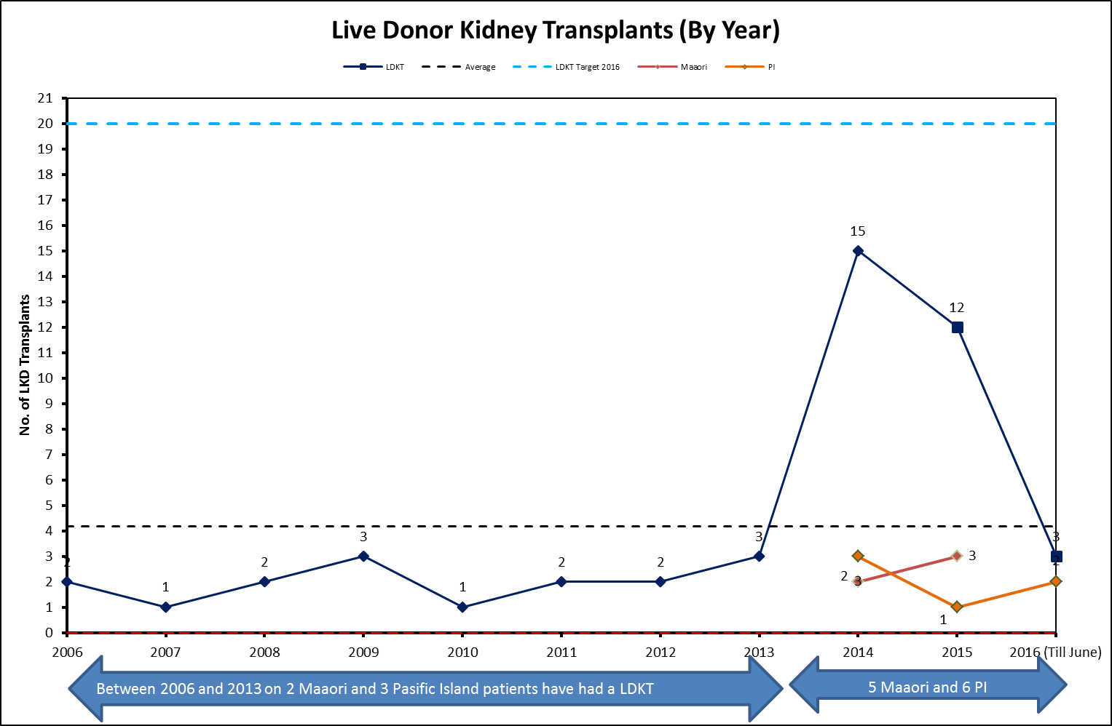

Live Donor Kidney Transplants by Month

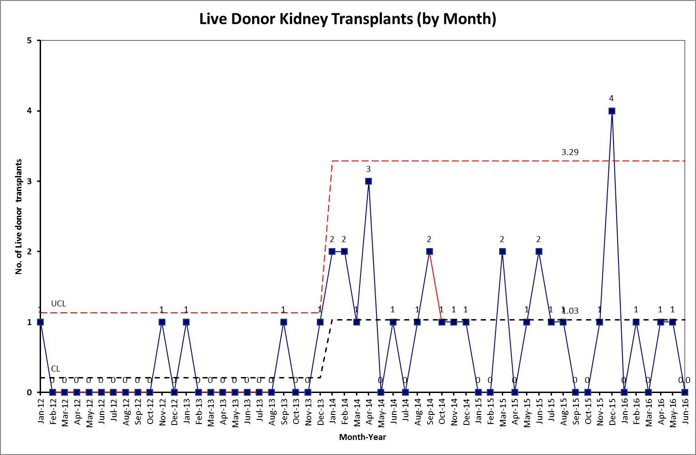

Total Kidney Transplants (Live + Deceased) by Month

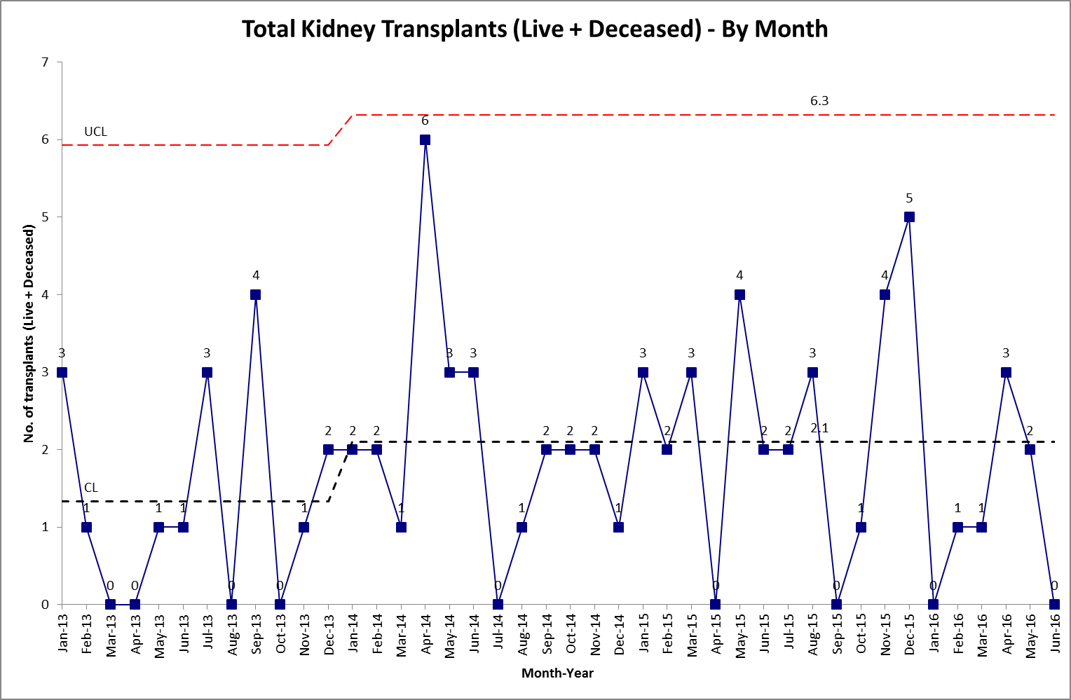

Pre-emptive Live Donor Kidney Transplants by Year

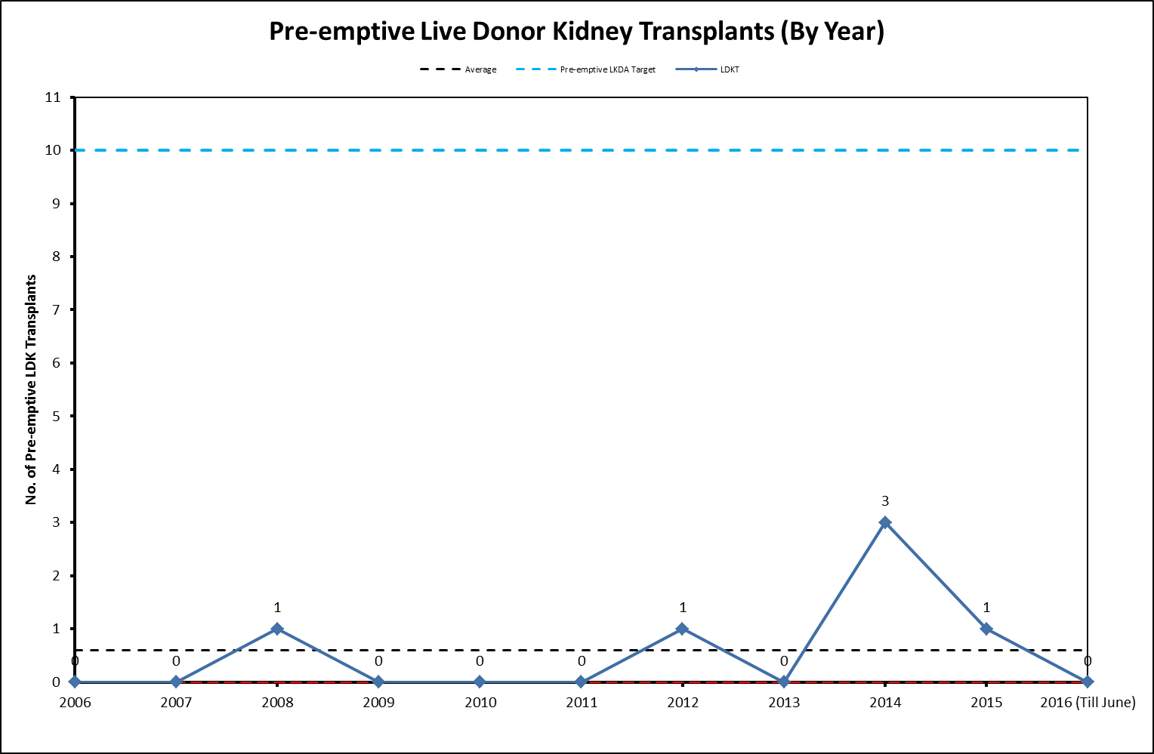

Live Kidney Donor Offers by Year

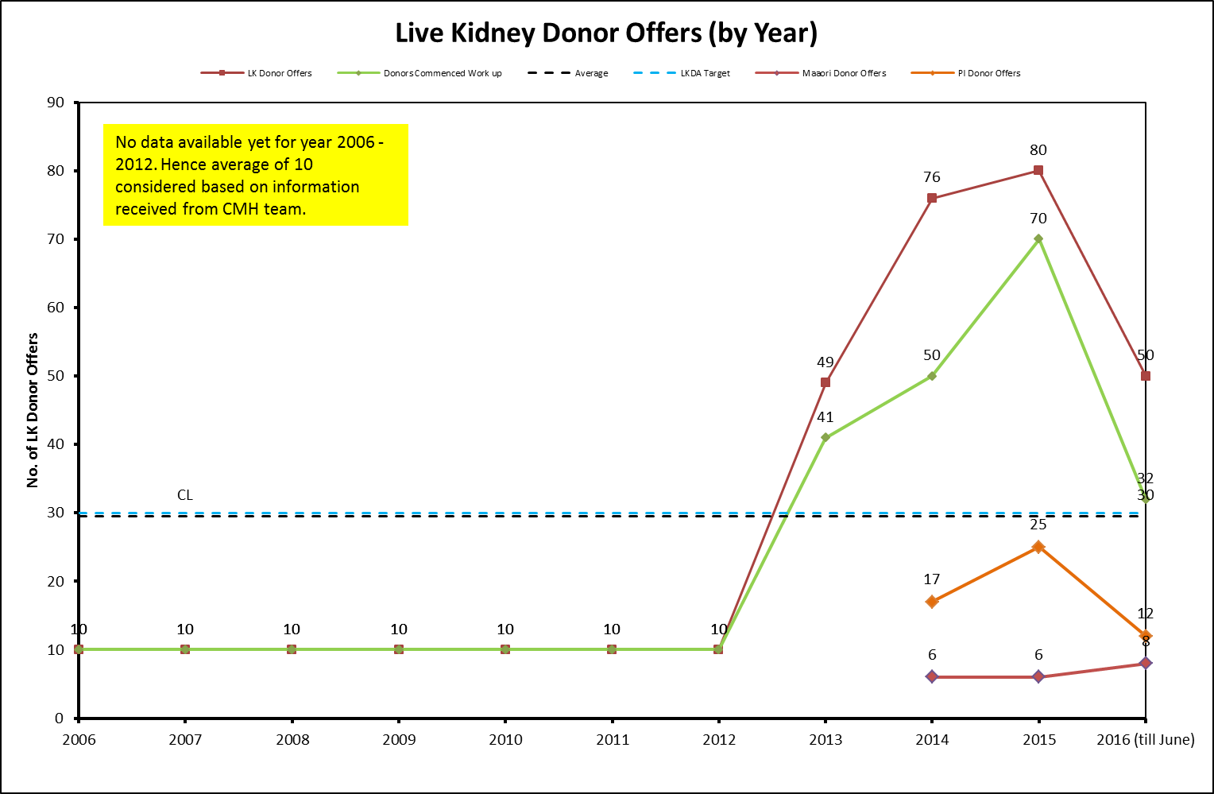

Number of Potential Donor Offers by Month

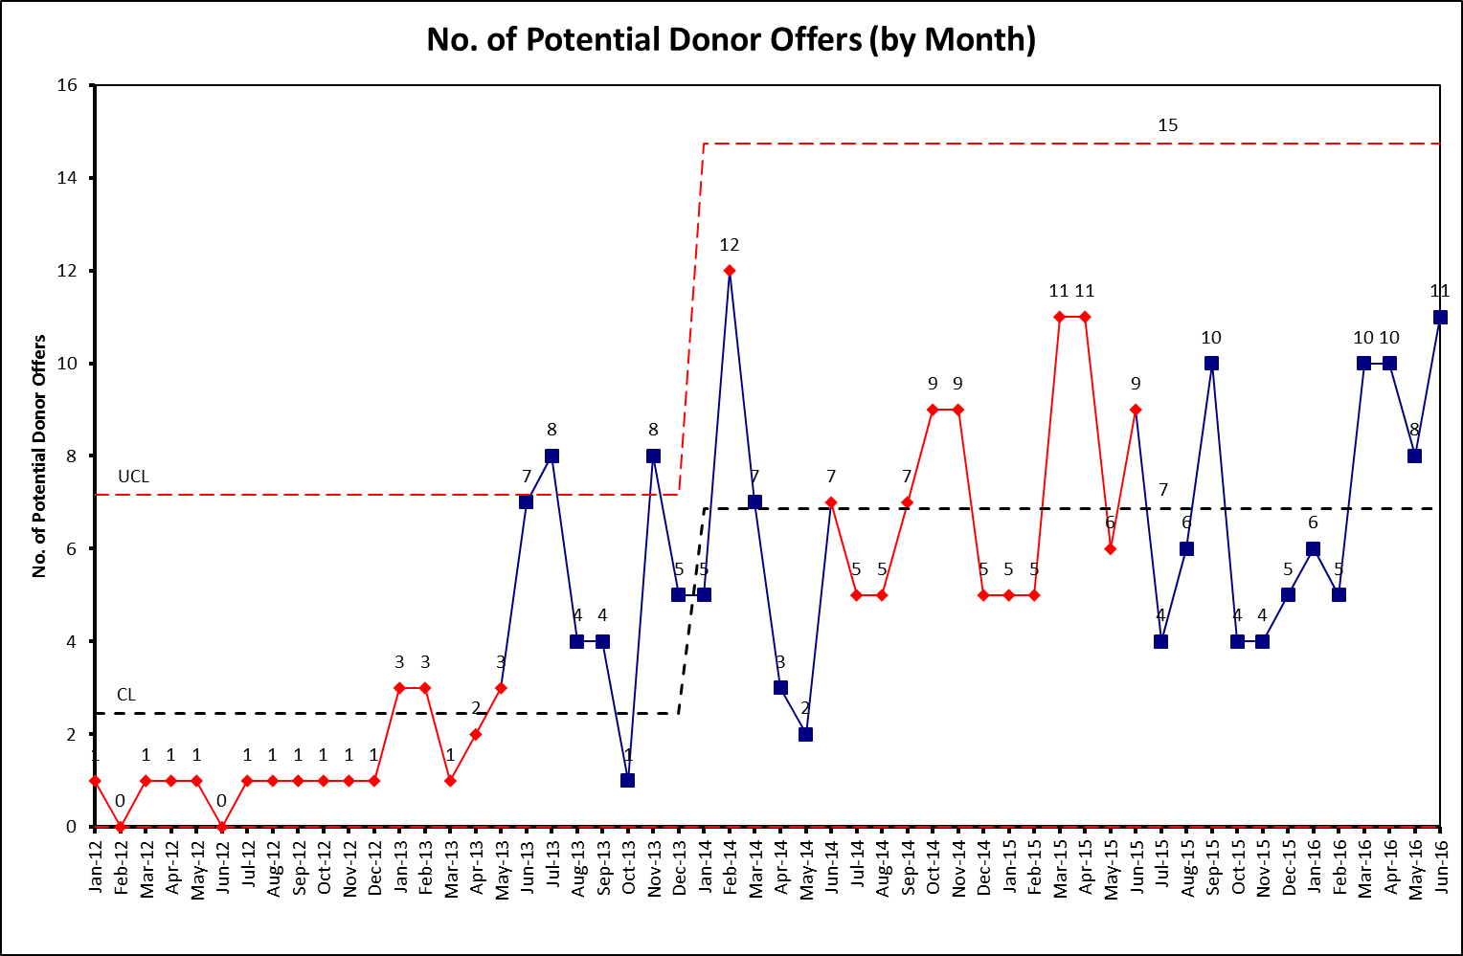

Home Based Education, Peer Support Programme and Renal Service Experience Evaluation Interview Guide

Home-based education questions
-What worked well? What did you like about the home-based education programme?
-What didn’t work well? What you didn’t you like about the home-based education programme?
-What should be changed about the home-based education programme?
-What is currently done in the home-based education programme that should be stopped?
-If you haven’t already received a kidney, what is getting/got in the way of receiving a kidney?
-What was it like to organise the family to attend the meeting?
-Did it change the way you and your family talk about kidney transplantation, how so?

Follow-up questions
-Would you recommend the programme to others?
-Did it help with making a choice to receive a kidney?

Peer-support questions
-What worked well? What did you like about the peer-support programme?
-What didn’t work well? What you didn’t you like about the peer-support programme?
-What should be changed about the programme?
-What is currently done in the programme that should be stopped?
-What is getting/got in the way of donating/receiving a kidney?

Follow-up questions
-Would you recommend the programme to others?
-Did it help with making a choice to donate/receive a kidney?

Live kidney donors that received usual healthcare services questions
-What helped you to donate a kidney?
-What made it more difficult to donate a kidney? / What got in the way?
-What should be changed about the kidney donation process?
-What would have made donating a kidney easier for you?
-What did you think of the information made available about kidney donation? (e.g. verbal information, books)

Pre-dialysis Education Evaluation Interview Guide

Patient interview schedule
- Introduction
  - Explanation of study, obtain informed consent
  - Collection of demographic information
  - What did you know about transplants before you saw the kidney doctors and nurses?
- Experience of education about live transplant
  - Can you tell me about the education you received about live transplant (where/ what who)?
  - What factors influenced your decision about live transplant? (recommendation/ preconceived ideas/ survival/ costs)
  - Can you tell me about the main things you remember being told about the benefits of live transplants?
  - Where there any things that concerned you about live transplant (yourself or donor)?
- Close
  - Is there anything else that you think is important to add?

Market Research Stage 1 and Stage 2 Reports

Attached as separate documents.

